Practical use of the semantic web: lessons learned and opportunities found
Reinout van Rees, Wouter van Vegchel & Frits Tolman
Faculty of Civil engineering and Geosciences, Technical University Delft, The Netherlands
This paper describes an early application of the semantic web, the lessons learned, and the research done afterwards on elements needing improvement. The scenario focused on private house owners that want a contractor to build an extension to their home for an enlargement of their living room. In the typical case, the client does not use the services of an architect, but deals with the contractor directly. The client’s perception problems and lack of building knowledge are a severe handicap in his dealing with the contractor and in his ability to communicate in a clear way the desired outcome. The research question was: “Is it possible to realise adequate support for this category of clients over the Internet?”
Semantic web technologies were used in an effort to build a prototype application to support the client. The semantic web supports linking an item in one semantic web file directly to an item in another file, so this mechanism was used to try out a number of separate co-operating ontologies instead of the usual single large ontology. In the last stage, to test out the integration with existing systems, the data describing the living room extension was coupled with two existing classifications, one for specifications and one for costing.
After the initial prototype, an evaluation was made. The tools used in the process were evaluated. The idea of utilising multiple co-operating ontologies worked well. Combining the data with existing classification systems was straightforward and fits in well with the overall semantic web system. Creating the content of the example ontologies, however, was an unsatisfactory part of the prototype development. Directly usable ontologies were not available, most were restricted to existing classifications or were small test ontologies. The most pressing problem was unclear separation between the functional and the technical viewpoint and their relation to the part-of problem.
In the final research the focus became the content of the ontologies and especially the functional/technical distinction. The second focus was the extension of the prototype towards the automatic generation of a building specification in a web services setting. The aim was to provide insight in the applicability of the semantic web regarding knowledge-oriented tasks.

Introduction
Meaningful (semantic) electronic communication in Building and Civil Engineering has been researched for many years. Success has been limited however. The bottleneck was the time-to-market of the standard itself. ISO-STEP produced paper-based standards that first had to be implemented by the application vendors before end-users could profit. AIA-IFC shortened the cycle somewhat, but at the cost of speeding up the number of new releases. With the arrival of XML a new approach became feasible. The European eConstruct project developed bcXML as an example of a web-based communication language for Building and Construction. With the newest OWL/RDF technology many problems disappear that eConstruct could not solve at the time. It seems that electronic meaningful communication is finally entering the arena ready to change Building Construction into a truly modern industry. At least that might be the case if the Semantic Web delivers what it promises.

Terminology baseline
To set a baseline for this paper, we will first introduce the semantic web and shortly explain what we mean with “ontology” and “classification”.

RDF: the semantic web's data model
The difference between the web and the semantic web is:
- Web: links from web page to web page.
- Semantic web: links from individual data item to individual data item, even when placed in a different file.
URLs used as globally unique id for identifying data items. The links themselves are also classified with an URL. Http://example.org/ont/Door (resource): http://example.org/ont/height (property) = “2.40” (value). Values can themselves be resources, like in http://example.org/ont/Door (resource): http://example.org/ont/material (property) = http://example.org/ont/Wood (resource used as value).
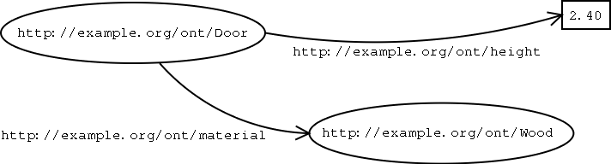
Figure 1. Visualisation of RDF data.

RDF sees everything as resource-property-value triples also named subject-predicate-object. When reading multiple files, an RDF application combines all data into one set of triples, so that data items with the same URL in both files are internally seen as one. This means that the information in the files is combined, making it feasible to have dispersed information that can later be combined. Also you can extend other semantic web files, for instance you can add your own extra levels to an existing classification system.

Ontology and classification
Both the term ontology and classification will be used in this paper. As discussed in (Rees 2003), these terms can be used to indicate multiple things, partly overlapping. The semantics suggested in that paper for classification:
Classification or “simple classification”. A grouping of entities according to some external criteria. The grouping will be quite natural, as it is mostly made from a certain viewpoint.
Classification is basically a set of boxes (with labels) to sort things into. It can be used as a user-friendly view on/in a taxonomy or ontology.
Likewise for ontology:
Ontology is a set of well-defined concepts describing a specific domain. The concepts are defined using an subclass hierarchy, by assigning and defining properties and by defining relationships between the concepts etcetera.
When using the term “ontology” an indication should be given of the kind of ontology. A very simple ontology could perhaps better be named “taxonomy”, but a heavyweight ontology should specify and advertise its capabilities lest it be grouped with the apparent majority of very lightweight ontologies.
An ontology's goal is to provide a common, reference-able set of concepts for use in communication. It is quite common to use multiple ontologies, each providing concepts for a particular domain, together forming a rich vocabulary for communication.
The intended semantics of ontology is a set of identifiable classes, placed at least partly in a subclass hierarchy, with labels and possibly descriptions, with associated properties.

OWL: the semantic web's ontology format
RDF makes it possible to identify and relate data items. This by itself is not enough. What is needed is to make the semantics of the data items explicit. An ontology can be used to define classes and to provide a list of properties associated with those classes.
Besides being a standardised (Owl 2004) web format for ontologies, OWL also allows a limited amount of reasoning. The semantics of the OWL model elements are well-defined, which is a necessary prerequisite for reasoning. When a certain property (say “door_height”) is defined as being only allowed on a certain class (say “door_leaf”), any object that has that property can be deducted as being part of that class. When needed, this allows you to define class A as being the same as class B, but excluding those objects that have property C.
In practice, you can for instance exclude objects from being a member of the class “load bearing walls” if they are not connected to another supporting load bearing structural element, like a foundation. This way you can detect possible failures – on the condition, of course, that the ontologies and supporting applications are detailed enough.

Implementation of a semantic web scenario
This section describes an implementation of a semantic web based prototype. Much of the work was done by graduate student Wouter van Vegchel (Vegchel 2004).

The scenario
The business scenario was directed to private house owners who want to improve and extend their houses. Typically, no architect is involved in such a small-scale project. But that means that the house owner (the client) has much less relevant knowledge than the contractor. This inequality can lead to problems.
- The client is unable to make his desires sufficiently clear to the contractor, leading to disappointments later in the process.
- The client is unaware of a lot of possibilities, and learns about unknown technical solutions and alternatives during the project.
- The client is unaware of a lot of risks, resulting in friction between the client and the contractor.
The basic premise is that it is possible to support the private house owner with relevant computer-based knowledge. House owner associations typically have a lot of data on common risks. Identifying these risks beforehand allows you to prevent the risk or to agree on the risk beforehand with the contractor, for example.
Providing the client in an early stage with multiple common alternatives for his wishes might mean more satisfaction because of a better fit between the solution and the wish.
Ideally, a simple, but good, building specification can be generated that can form a basis for a better and clearer contract.
The technical reason for this scenario was to provide a back to back walk-through of a complete semantic web enabled building information exchange. There are so many clients that have the same problem as our private house owner, though on a large scale. A small experiment to learn about the technology, its features, and its limitations seemed worthwhile.

The Ontology: basis for communication
Obviously the semantic web was a pre-requisite for this research. Therefore definitions of objects used in the communication (house, extension, addition, foundation, roof, height, and so on) were made explicit in an on-line ontology. As the Building Construction industry is strongly fragmented, instead of developing a single huge ontology it seemed a good idea to create multiple smaller cooperating ontologies, each for a certain domain. Ultimately domain experts have to create the ontologies for their own domains. If estimates are correct some 300.000 objects with properties and units should be described; clearly not a small project.
Using OWL this possibility is becoming a real alternative, as OWL allows the mixing of multiple ontologies. This is the semantic web in action: on the web you can link from one document to another, on the semantic web you can link from one data item in one location to one data item in another location. So a “mechanical ventilation system” can have a “subclassOf” link with a more generic “ventilation system” in another ontology.
In the initial implementation a number small ontologies were created using Protege's (protege 2004) ezOWL (ezowl 2004) plug-in. The ezOWL plug-in provides a graphical UML-like interface, but beyond a few dozen classes the display becomes overcrowded. The ontologies contained the modest ad-hoc needs for the prototype implementation. The top ontology described various types of private houses. This ontology used sub ontologies for Roofs, Walls, Foundations and such. For example the roof ontology described various alternative roofs the user can choose between. The roof system was broken down into great detail, i.e. down to side board and such.
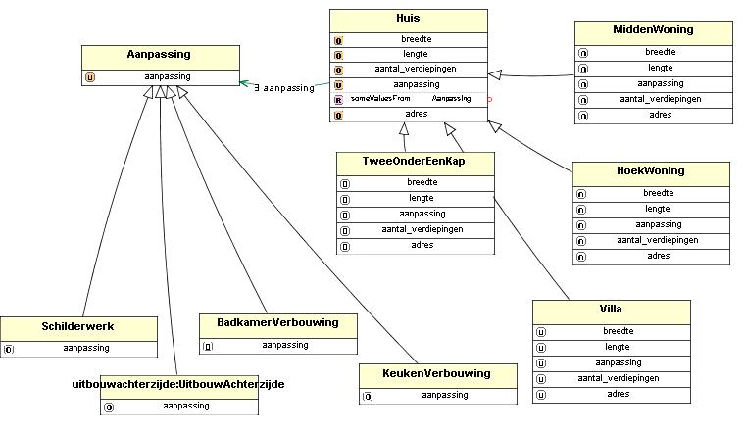
Figure 2. Example of the structure of the small ontologies.

Protégé is a very powerful tool that already exists for a decade. Protégé is extremely powerful as an information modeling tool, though basically only supports the subclass relation as object structuring mechanism. This scenario's implementation added a limited part-of relation, as it was needed. Using Protégé, the main structure of the home extension ontology consisted of small two-level hierarchies. Each two-level hierarchy focused on a particular end-user choice. The subtypes were mainly technical solutions for a more generic concept. The more generic concept was often used as the target for either a relation or a part-of relation.
The prototype was implemented for a simple extension at the back of the house. After making the required choices and filling in some properties for his project, a small instance model is available for the client.

The customer support tool: generating a design
With the concepts stored in the ontologies, a prototype web application was made that supported the client in his awareness and decision process. The main focus of the effort was to use as much as possible only the ontologies.
The starting point, a house, is fixed. But the application retrieves the available subclasses of “House” and presents them as choices to the user. The selected class is then polled for attributes, which are presented to the user (flat or tilted roof, for instance). The design can be used as the basis for a visualisation (Figure 3) following the research of eConstruct (Rees et al. 2002) where VR shapes were generated as mark-ups from bcXML content files.
It is fair to say that, though the user seemed to have a lot of choices, the set-up strongly resembled the principle introduced by Henri Ford (a T-Ford can be delivered in any colour, as long as it is black).
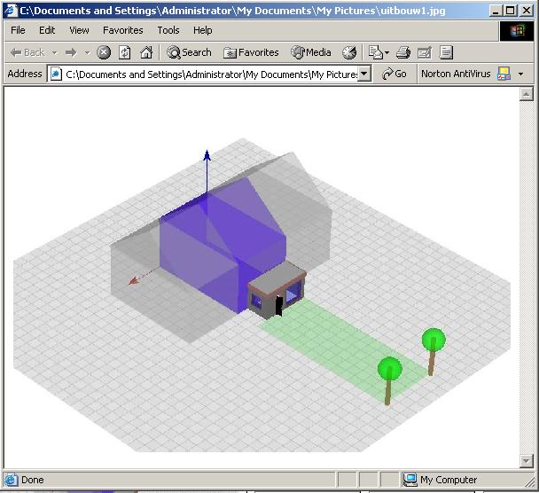
Figure 3. Visualisation of a house with an extension.

Knowledge modelling
The next step was to look into the knowledge modelling capacity of OWL. OWL DL (Description Logic) strongly resembles its predecessor DAML/OIL (DAML/OIL 2001). DAML/OIL has been around a couple of years and experience with description logic, or logic programming, is amply available.
As a test case the applicable rules in the building regulations have been added to the ontology. As these rules are simply of an if-then-else type OWL had no problem with them. In fact it seems that OWL DL and OWL Full provide a strong basis for this type of applications and opens up a whole new market for knowledge vendors (including R&D institutions). Though time became rather limited we looked into the possibility to check the designs against a knowledge base that contained knowledge to prevent construction errors. From what we did it seemed that this type of services can be nicely build on-top of the ontology network. As many other services spring to mind from costs, risks, to a multitude of analyses, the idea took shape that this might become a whole new way to market knowledge.

Coupling with specification systems: using the available data
With the instance available, we made a coupling with the Dutch specification system. A problem is that the Dutch specification system does not support such small projects without an architect (it is both an implementation and a legal problem: there are two differing legal frameworks, one for small works like these and one for bigger works with architects, subcontractors, etc.). The work done is therefore just for test purposes.
The starting point was a text-based specification which was converted into an xml-formatted file (just text conversion). That was transformed (using xslt) into two separate semantic web RDF files, one for the specification's chapter structure and one for the actual specification items content.
The instance was an RDF file pointing to the concepts in the ontologies. A file was created that specified the mapping between concepts in the ontologies and specification items. For example, “House” is the starting point. The mapping file specifies that for the opening section of the specification, naming the project, the address and the description of the extension have to be extracted from the instance. This mapping was, of course, done in RDF.
The mapping used both “push” and “pull”. The specification “pulls” the info needed in the opening section (the house's address, the extension description) from the instance. But it just reacts (“push”) on a lot of other items. It only includes a section on brick walls when the instance “pushes” the brick wall to the mapper. In a way, this simple solution mimics XSLT's behaviour.
The result is an RDF file with just the specification items, but without a chapter structure. A small program adds the relevant chapters from the separate chapter RDF file, generated previously. This is converted to HTML at the end.
An interesting addition to this process was the conversion of the Dutch SfB classification table (nl-SfB, “elementenmethode”) to a similar chapter structure and adding the links from these chapters to the specification items. Without changing anything in the original data, this second chapter structure could be combined with the resulting specification items and transformed to HTML as an alternative building specification.
To be more accurate, the first specification structure is a work breakdown structure, which is the structure of the Dutch building specifications. The second classification (nl-SfB) is normally used (in the Netherlands) for costing applications and CAD drawing layering. As a side note, work is underway to make the nl-SfB an alternative for the work breakdown classification in the building specifications.
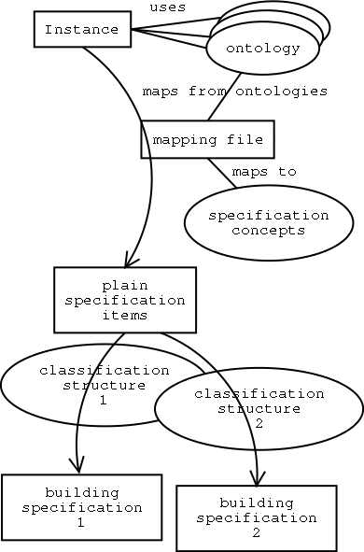
Figure 4. Specification generation

Discussion on the implementation and further research

The basic scenario as a whole
Storing the base data in ontologies worked well. Both the support application and the specification generator could use it as a basis for communication. The possibility of subclassing (inheritance) was used well by both applications. The client support application displayed different kinds of houses (subclasses of “House”), the specification generator needed a “House” instance as a starting point, but reacted also perfectly to an instance of a subclass. This might not seem like a big deal, but there are not many current applications that have such a thing build-in.
The real support of the client by warning him for common pitfalls etc. was not undertaken because of time constraints. In this way, only the generation of a simple specification as a basis for a contract provides a bit of support. On the other hand, the ontologies contained common solutions for house extensions, preventing possible omissions.
Regarding further work on the instance model, the next stage is obvious: a real interaction with CAD-based data. The only currently realistic option is IFC. When looking at a semantic web supported scenario, it makes sense to use ifcXML. As a baseline, ifcXML files should be downloadable on the Internet, but it makes a lot of sense to expose the normal IFC data store functionality on the Internet. Http://example.com/building42/2nd_floor could return an ifcXML file with all elements on the second floor, http://example.com/building42/doors could return all doors in the model.

Ontology development
The ontologies created were ad-hoc. The only objective was te support the selection of alternative technical solutions. The small modelling needs of the case study provided the classes for the ontologies.

Ontology sources
The problem is that there are no ready-made ontologies available. With “ontology” we mean basically a set of classes and attributes. There are a few projects aiming at creating such an ontology and there are a few starting points for ontology developments.
- 12006-3: LexiCon, Barbi, SDC. (Includes eConstruct's taxonomy, as it was LexiCon-based). No definitive, usable results are available yet.
- 12006-2: SfB-like system, but mainly a basis for classification systems. The objective is to harmonise national and regional classification systems. The (inter-)national SfB variants have tables with useful classes, but they are not coupled with attributes. Those tables can be a good starting point, though. Classification systems are cornerstones in ontologies as they summarise and organise existing knowledge (Ekholm 2004).
- E-cognos ontology: mainly collection of existing classification systems (BS6100, Uniclass), so missing attributes.
- IFC has both classes and attributes (property sets), but separated from the standard. The choice of classes and attributes and their definitions is in first instance based on object oriented CAD packages (broadly spoken). It is a limited set, but the reasonably widespread use of IFC and the attractiveness of a coupling with a CAD system make it a good candidate for inclusion or coupling. TNO (the Netherlands) has extracted the classes and property sets as an OWL file. The XM7 project harmonises 12006-3 with IFC.
A more detailed discussion can be found in CWA4 (CEN Workshop Agreement ), available at http://www.nen.nl/wseconstruction.

Ontological business needs
For ontologies to be created and used, they have to fulfill real business needs. The two places in the construction process where money can be seen most readily are the following:
- Procurement: searching, buying and selling of construction materials.
- Selection of technical solutions for designed objects; the coupling of a design or designed elements with a contractor's offering or possible technical solutions.
On a higher level, both can be seen as a matching process between supply and demand.
Objects and properties can be viewed from a functional perspective (demand) and a technical perspective (offering, supply).
Functional objects have functional attributes, or better, functional requirements. Unless the client demands a specific object, the demand specification will normally be phrased with functional requirements. An example is provided below. A technical object or, technical solution is a specific object like a brick wall.
In between the functional demand specification and the possible technical solutions there ought to be a matching process. The functional objects in the ontology should therefore be specific enough to allow suppliers to automate the matching process of those functional objects with their products.

Some implications
Ontologies can perhaps best be seen as basic pieces of infrastructure, the costs of which should be shared. Non-proprietary and a shared workload: open source. If the advantages of generally available ontologies are realistic enough, investing in coordination, some infrastructure and the man-hours needed to fill the ontologies should be possible. In other (richer) industries like the medical industry huge ontology building efforts are taking place. Their ontology web, UMLS is said to contain over 700.000 objects. The advantage of ontology based information and knowledge sharing are obvious: a priori integration (if based on the same ontology, applications can communicate) instead of the commonly used a posteriori integration. It seems that in Building Construction the government has a large stake in the development effort (provided that the results are open and given enough momentum market forces can take over) because there is so much at stake and so much tax payer money spoiled each year.

Future work
The approach followed in the presented research, combined with the indicated demand/supply direction, gives us a few very interesting research topics.
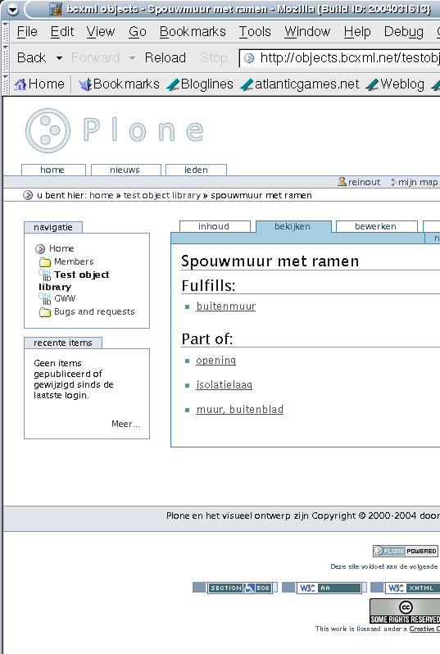
Figure 5. Prototype web-based functional unit/technical solution editor.
First ontologies. The functional unit/technical solution FU/TS paradigm proposed in the General AEC Reference Model GARM (Gielingh 1988) seems useful, but it needs to be tested with a sizeable set of data. This directly draws attention to the part-of relation semantics. Taking just eConstruct's ontology as example, it was never clarified whether the parts indicated in the ontology were a definitive list or just a suggested list of common parts, or a set of obligatory parts. FU/TS includes the decomposition of a technical solution into a few smaller functional units and so could be a good basis for a clarification. The ISO standard 12006-2 is partly functional-based, partly technical-based, so this common classification needs attention.
A second subject of interest regarding ontologies is the specialisation hierarchy. This mechanism is very useful, especially for data reduction. From a scientific viewpoint it is interesting to try to combine the specialisation hierarchy with FU/TS decomposition using multiple, smaller, ontologies as shown in this research.
A third challenge is to get an open source like ontology development off the ground. This needs a good web-based interface for cooperative ontology development and a good, clear license. Preliminary think work suggests that a “creative commons” license (http://www.creativecommons.org/) might be a good choice.

Web services
This section provides a view on the possibilities of web services. Information from several sources, available in web-readable formats, is combined into a new result. The actual implementation of the client support application is independent from the specification generation, as only the readable result that is transferred over the Internet matters.
Note that in this case we only transfer files (XML, RDF) using the normal Internet protocols (HTTP), we are not defining a custom SOAP API for every application that has to be implemented by the other applications. It is recommended to not use SOAP unless absolutely necessary.
SOAP raises the coordination costs with the number of attached applications. For each different application (identified by an address) you need another API. HTTP is always the same, so more applications do not raise the coordination costs, apart from the extra addresses (naturally).

Semantic web as knowledge support
A other interesting area of research is to look beyond the obvious advantages of semantic web based ontologies. The obvious part is having easily usable object and property definitions. The less obvious part is the built-in support for knowledge support. OWL supports a basic level of reasoning. It allows you to define classes as the set of objects fulfilling a set of criteria. A certain class of houses can be defined as having an internal sound level that is lower than a certain value. Existing houses (or designed houses) can than be tested if they are part of that class. This allows an integrated handling of some types of regulations.
Likewise, regulations can define a certain class of doors to have a minimum width (for safety reasons). A public building can require all doors to be part of that safety class.

Conclusions
A common network of object definitions (including properties and units) first should satisfy the needs of the national industry. This has been one of the lessons learned from the European eConstruct project where endless discussions about the nature of very common objects (like inner doors) proved beyond reasonable doubt that different concepts are applied in different European countries. French inner doors differ from Dutch inner doors and German inner doors. The same is true for most objects, large and small. Standardisation efforts of data describing Building Construction object definitions should realise this fact. Only after each country has defined its own objects, European or even ISO standardisation comes into play. The case study presented above clearly confirmed that conclusion. Everything contained in the ontology is coloured by national regulations: the type of houses, the type of extensions, the type of walls, foundations and roofs, the details of the constructions, everything.
Interesting is that the purpose of the ontology reflects in its structure. Supporting the client in his decision making process makes it mandatory to distinguish between a functional view and a technical view. In the small this has been implemented and demonstrated. How it should be done for large projects is a question for the future.
Also rather interesting is that ontology-based web services might well change the future of software and service providers. Ideally web services should be implemented as Virtual Experts. Paying only for the time the service is actually being consumed and not for the availability of the applications seems quite interesting for the clients, though maybe somewhat fearful for the vendors or their service staff (vendors only have to support one version of their software!!). The case study learned that it might well be possible to develop support for all kinds of knowledge-rich services like cost analysis, risk analysis, specification, feasibility, maintainability, and much more, and make that support available on every PC over the Internet.
Also interesting is the possibility that new players may enter the market. R&D institutions can transfer results of research into usable services instead of new regulations, for example to provide knowledge intensive services, such as analysing designs for possible design errors, or transaction risks.
All in all the case study proved to be useful. The semantic web brings challenging opportunities for improved information and knowledge sharing which, in time, will change Building-Construction as we know it into an industry that intensively co-operates to truly fulfill the clients’ demands.
References
DAML/OIL 2001. Reference description of the
DAML+OIL (March 2001) ontology markup language. Available on-line at http://www.daml.org/2001/03/reference
Ekholm, A. 2004. ISO 12006-2 and IFC – could they be harmonized? Unpublished, w78 workshop Toronto 2004.
Ezowl 2004. Visual semantic web ontology editor. Available on-line at http://iweb.etri.re.kr/ezowl/
Gielingh, W. F. 1988. General AEC reference model (GARM). Delft: TNO bouw.
OWL 2004. OWL Web Ontology Language Reference. Available on-line at http://www.w3.org/TR/2004/REC-owl-ref-20040210/
Protege 2004 Protege ontology editor. Available on-line at http://protege.stanford.edu/
Rees, R. van, Behesthi, R., Tolman, F. 2002. bcXML enabled VR project information front-ends. Ework and ebusiness in architecture, engineering and construction. Lisse: Balkema.
Rees, R. van 2003. Clarity in the Usage of the Terms Ontology, Taxonomy and Classification. Proceedings of the 2003 cib w78 conference. Auckland. Available on-line at http://vanrees.org/phd/Cib78ConferencePaper2003.
Veghel, W. van 2004. Het bouwportaal. (Note: master thesis in Dutch). Available on-line at http://www.woutervanvegchel.com/afstuderen/BouwPortaalFinal.pdf

