BcXML enabled VR project information front-ends
Ir. R. van Rees (R.vanRees@citg.tudelft.nl)
Delft university of technology, Delft, The Netherlands & STABU foundation, Ede, The Netherlands
Dr. Ir. R. Behesthi, Prof. Ir. F. Tolman
Delft university of technology, Delft, The Netherlands

ABSTRACT: The paper describes how Virtual Reality project information front-ends (Project Webs) can be built using bcXML, the Building-Construction specific XML language developed by the European eConstruct project. The idea is that VR can be used to create common insight in the project between all parties involved. However, the ‘traditional’ VR is only focusing on modeling the shapes and textures of the objects that form the facility. Though this might help - especially in PR - such project webs are not very useful as common sources for project information. The purpose of the paper is to describe how bcXML can be enhanced with multi-media (shape, texture, speech) and how such a technology can be used to create Project Webs that can be used as information front-ends to store and retrieve project information.

IntroduCTION
Though bcXML and its supporting taxonomy will enormously help the Building and Construction industry in it’s effort to change its traditional paper based way of communicating into an electronic way of communicating, in many human communications 'a figure says more than a thousand words'.
The objective of this paper is therefore to investigate how bcXML communication involving humans can be enhanced by multi-media support, especially by 2D vector graphics and 3D Virtual Reality (VR) for accessing project information.
A Project Information Front-end (PIF) can be used to support electronic meaningful communication between all parties (humans and applications) involved in a project. Typically a VR PIF is communicating with a project database that holds a detailed description of the project.
To fully understand the aim and the reason for this research, consider an average one-of-a-kind construction project in the public sector, involving participants, suppliers, authorities, and the general public. In some cases thousands of people, all with daily or even hourly requests for information. Then imagine a project where people from different nationalities are co-operating to reach the required result, and notice yet another source of miscommunication and consequently of cost of failure.
What if all parties involved can have access to a virtual world describing the project in detail? Some detail though, not great detail, because the VR project world is used to support general information retrieval not detailed shape. Real CAD data is IFC’s terrain!

Bcxml: the Econstruct language
BcXML is the internet communication language for the building and construction industry developed by the eConstruct project (IST 10303, February 2000 till February 2002). This section provides a quick overview of its XML data and visualisation.

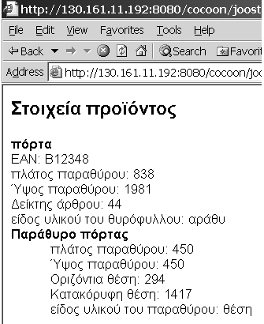
Figure 1. Multilinguality in bcXML: textual Greek door ('porta') information

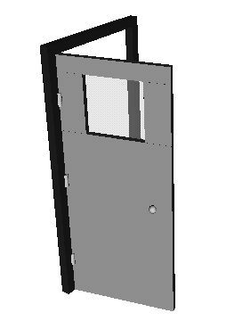
Figure 2. 3D image showing opening direction of a door.

LexiCon
The LexiCon is a taxonomy for the building and construction industry build by the Dutch STABU foundation, mainly within the eConstruct and CONCUR projects. It is an implementation of the ISO-PAS 12006-3 proposed standard 'framework for object-oriented information exchange'.
To facilitate easy information exchange using bcXML, a structured set of definitions was mandatory. The LexiCon provided us with those definitions of objects, their properties, units, measures, etc. Every item in the LexiCon has several translations attached, so it is multi-lingual from the beginning. In eConstruct, the LexiCon was filled with six languages and the demonstrations showed the language-independency and the Lexicon's capability to serve as basis for all communication.
Based on the definitions in the LexiCon the bcXML language (i.e. XML format) was generated. A good source of information on how bcXML handles construction semantics is (Rees 2002).

Distinction between content and mark-up
Different representations of the same data are possible by applying different mark-ups to the same content. Content is what you want to communicate and mark-up is how you want to present the content on paper or on the screen. For eConstruct this XML feature is interesting because in multi-lingual communication the mechanism can be used to display the content of a message concurrently in different (European) languages. But mark-ups are not limited to text, graphical formats or speech output are also possibilities.

Textual visualisation
The easiest handling of bcXML information is textual visualisation such as Figure 1. The information can be filtered to include just the desired information and can be displayed in multiple languages.

Graphical visualisation
When no real interaction is needed, a simple textual (html) or 2D visualisation (SVG, scalable vector graphics XML format) can be used. Adding vrml and animation allows for displaying for example of the movement characteristics of items. A detailed description can be found in (Tolman 2001). Figures 2 and 3 show some of the possibilities.
A problem is that visualising new components or assemblies should not require programming as this would require skills that are clearly not presently available in the BC industry. This means that most shape and topology information should be inherited from a small set of basic building blocks as described in (Rees 2002).
Though bcXML was not specifically designed with simple project visualisations (such as Figure 3) in mind, no problems were encountered. This simple type of project visualisations is quite important in the BC industry as very often the design or realisation of some part of a project (also in the case of the house example above) involves people from different disciplines that are located in different offices, cities and sometimes indeed countries which can benefit greatly from bcXML's capability for easy (language-independent) information exchange. Project visualisation does not handle detailed shape though, real CAD data is IFC's terrain!

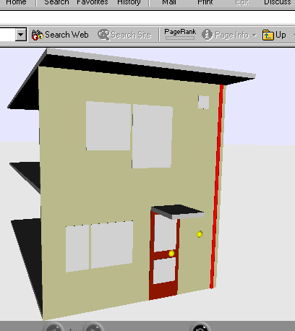
Figure 3. Example project visualisation of a house.

Use of bcXML content only
Apart from visualisation, operating on only the data is, of course, also possible. Data can be checked for compliance according to building regulations ('does this doorset's fire resistance meet the regulation for office building’s?'). Or the data can be read by an accounting package, for instance.
Handling the same content in different ways is very essential. XML is made to make information exchange and handling easy. A lot of the standards surrounding XML (most notably XSLT) specifically provide ways to change the data into a different format.

Summary
BcXML uses a LexiCon-based XML format for its data. XML's separation of content and mark-up allows both very varied visualisation and real data handling.

Accessible web-based data
XML has claimed a large share of the data exchange market and the internet is used everywhere. But a lot of the XML-based information is hidden within internet applications. This section introduces an approach that allows for project information to be really accessible.

Webify data
Webifying data means that every piece of useful data should have a URI. The success of the World Wide Web is entirely based on assigning a URI to every webpage and image and enabling links between them. Every object on the internet is accessible directly, be it http://www.cnn.com or a page describing the lodging facilities for 2002's ECPPM conference.
Webifying a door catalogue, for example, in this case doesn't mean having one human-readable page containing pictures and some text listing the available types. It means having your catalogue available at http://compagny.co.uk/doorcatalogue and the parts describing the various individual doors at http://compagny.co.uk/doorcatalogue/door1 etc. This makes it possible to link to a specific door in you catalogue from the project where they want to use your door.
It stands to reason that both the 'original' bcXML data and possible visualisations/conversions should be accessible through URI's.

Semantic web
Webifying data is the first necessary step to enabling the so-called semantic web for the building and construction industry. Semantic basically means 'data with meaning' which is what bcXML is. Add a set of definitions like eConstruct's LexiCon and the data is understandable for computers. This is the level currently reached by eConstruct.
This level opens up the way for automated logic operating on the data made accessible. Eventually checking your project data against various legal requirements could be one of the possibilities, for example.
Though still largely academic, technology like this is a natural extension of the internet. Thereby it is another reason to both webify the data and to use a LexiCon approach. For more information, see (Lee 2001).

Internet architectural style for applications
What made the web work besides URI's and standardised data formats (first HTML, now XML) was the http protocol (hypertext transfer protocol). Http defines basically four operations on URI's. Of those four normally only “GET” is used. If you request a certain page in Netscape you send a “GET” request to the webserver hosting that page.
Like SQL's SELECT, UPDATE, INSERT and DELETE on database rows, http offers GET, PUT, POST and DELETE on URI's. GET a door catalogue item, PUT a different door in your project's data, etc.
Using http in this way for accessing building and construction data also adds the following benefits:
- Standard http authentication (username/password protection).
- Https: secure connections (also used for internet banking).
- Standard http caching mechanisms and load balancing.
The pure http approach differs from the currently much-hyped SOAP approach, which allows you to invoke applications over the internet directly using custom-made interfaces. This has the drawback that it circumvents the normal internet safety, security and caching mechanisms. This forces you to implement your own access control, encryption methods, etc.
The building and construction industry is heavily fragmented and the last thing it needs is a large number of custom-made interfaces instead of a completely standardised data access and modification mechanism as offered by http.
The definitive resource is the thesis by one of the web's architects (Fielding 2000), a gentle introduction can be found on-line in (Prescod 2002).

Human access and computer access
It is essential to allow both applications and humans access to the data available. Items in your catalogue should be both displayable to humans (using an ordinary browser) and available for applications (in the bcXML format) for instance. Data available to your users as html pages with images is probably also useful for applications in order to put a stop to the endless re-entering of information when going from one island-of-information to the next. On the other hand, data you provide for other applications probably can be made more useful by adding a simple html view on that data so that a single PC with internet access is enough to access the data for quick inspection and information exchange.

Summary
URI's, standardised data formats and the standard http protocol are what make the internet work. As the building and construction industry is too fragmented, proprietary solutions will fail, so everything must have a URI and XML and http are mandatory.

Web-accessible bcXML project data
With bcXML, visualisation and web-based data, interactive project front-ends can be made. After an introduction and a list of requirements this chapter proposes several approaches. Safety and permissions are discussed also.

Use case for VR project information front-end
Virtual Reality (or more general multi-media) information front-ends display 2D and/or 3D images (including text windows) of physical objects or 'worlds' on a computer screen and support the users to navigate through the VR world and to look at the images from inside and outside. A Virtual Reality information front-end is a piece of software that helps the user create, modify and retrieve information about the physical object displayed on the screen.
In the future construction projects will be represented in such a way that all parties involved - including the authorities and the general public - can navigate the virtual project world and find and provide the information of their interests. Users can enter these project worlds over the Internet, navigate to the area of their interest, click on objects of their choice and find whatever information they are looking for.
The ultimate goal of a VR Project Information Front-end is to support the inter and intra project communications required during the project life cycle and beyond, not only involving project partners and suppliers, but also the authorities and the general public.
These requirements do not imply that the VR project world displayed on the screens should be very detailed and that the underlying shape model formally defines the geometry and topology of the facility! Abstracted shapes and textures are in most cases sufficient and detailed topology (i.e. how a beam is exactly connected to a column) is not relevant, those aspects can be hidden from most users.

Requirements
The following requirements have to be met by the VR Project Information Front-end:
- Unlimited availability. - Only a standard browser plug-in and a standard like SVG and X3D/vrml should be applied.
- Supports browsing a meaningful project world. - If a user clicks on a column the system should know it’s a column, should know its designer or its geometry, and should be able to display all its relevant properties.
- Applies information hiding. - Applying principles of information hiding like decomposition and views is mandatory, otherwise too much irrelevant information obscures the screens. Also facilities for progressive detailing, as required in the global to detailed design stage, should be supported.
- Is selective. - It is also necessary that the system can be more or less selective and open for different types of users. Not everybody should for example be able to find financial data.
- Is multi lingual. - As large-scale projects nowadays always involve partners and people with different backgrounds and native languages, the PIF should support communication in different languages and alphabets.
- Is bi-directional. - The PIF should - at least to some extend - be able to support user input. In co-operative design for example the electrical engineer should be able to change the number and location of electrical plugs.
The list of requirements can of course be extended, for example with the possibility to scroll back and forwards in time, or with the possibility to use voice controlled input, or to hear the sound of the piling works next summer. Though these and other extensions are not being looked into, it seems obvious that there are no hard reasons that indicate that they cannot be implemented.
Most of the requirements listed above can be realised by using bcXML and the component and project related multi media extensions developed earlier, but with added bi-directional communication.

Bi-directional communication
Highly interactive and dynamic interfaces are certainly possible, but these will require a tremendous amount of work to make the solution generic enough to work with all bcXML data. Also, highly interactive means a steeper learning curve, more computing power and more bandwidth. Therefore a number of simpler solutions are proposed to add interactivity to bcXML project data.
Just like descending in a web hierarchy by clicking through, a vrml file could support clicking on visualised items to drill down to more detailed levels. This uses the decomposition relationships between the building elements. If a wall with a window and a doorset is shown and the user clicks on the doorset, a new vrml file is fetched showing the frame, the hinges and the door leaf. This is possible if every useful object has a URI as discussed in the previous chapter. Clicking on one of the parts (say the window in a door) should request that part's URI, returning a generated vrml representation.
Secondly, a vrml file could be requested in edit-mode. Objects for which the user has change permission should be movable. By dragging an electrical outlet to a different location the electrical engineer could participate in a co-operative design session.

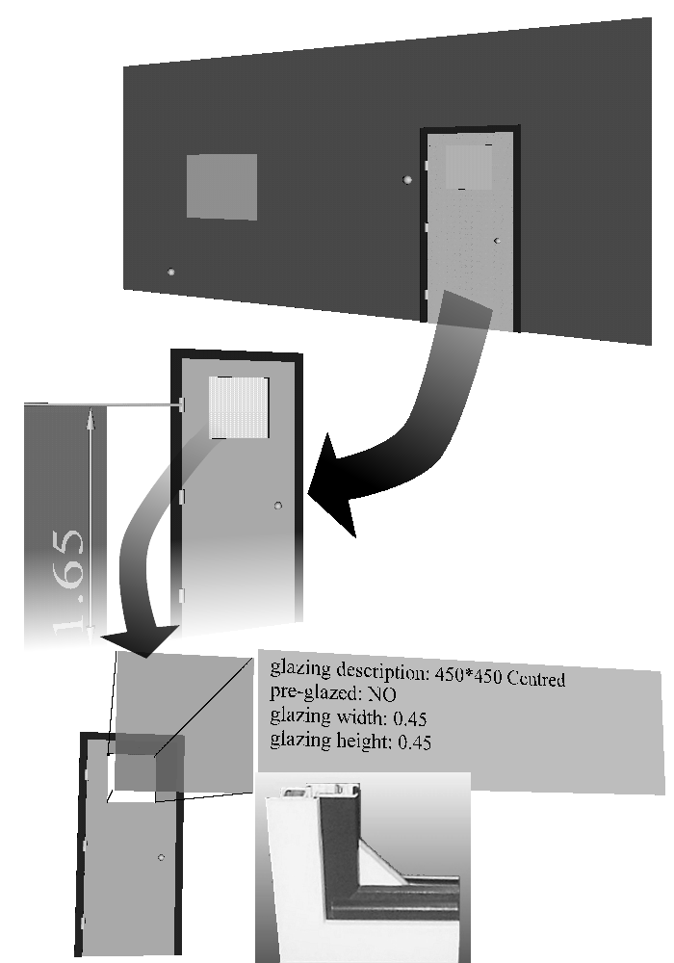
Figure 4. Clicking through to finer levels of detail.
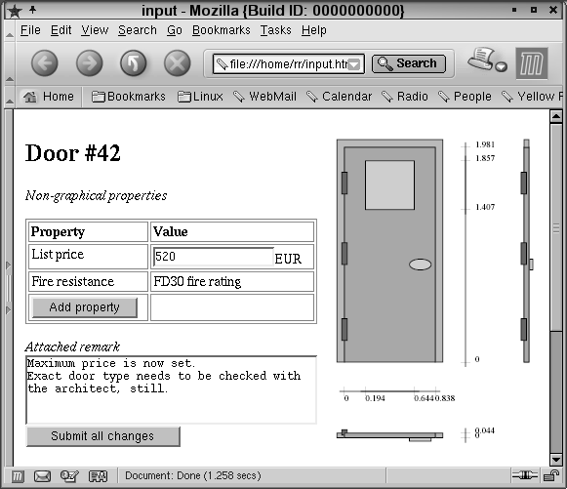
Figure 5. Shape information displayed as image, on the left the attached properties best displayed as text. Also, an attached memo is shown.

A thirth option is to display an html page next to the image displaying the non-graphical properties. For applicable properties a drop-down menu with possible values or a text entry field can be offered. This way, users could update repair status, set a maximum price, attach a memo, etc. without cluttering the image with too much information and cumbersome data entry.

Security and permissions
Security and permissions can be a big cause of concern. Who is allowed to access the financial data? How do I know for sure my competitor won't steal my design? Won't I change objects for which I don't have permission to do so?
If purpose-build interfaces are used, these fears are more than justifiable. Technically, every system can be made secure, but a lot of effort and testing is needed to make sure that the special build solution really works as intended.
If, on the other hand, the internet architectural style for applications (chapter 3) is used, a lot of the mechanisms are already in place. Http based authentication can be used from every programming language and most web frameworks have support for the UNIX-style user/group/guest permissions. Https connections can be used to make sure only encrypted data is sent over the internet. The current internet runs on the same technologies and if they are safe enough for internet banking then they are also safe enough for building projects.

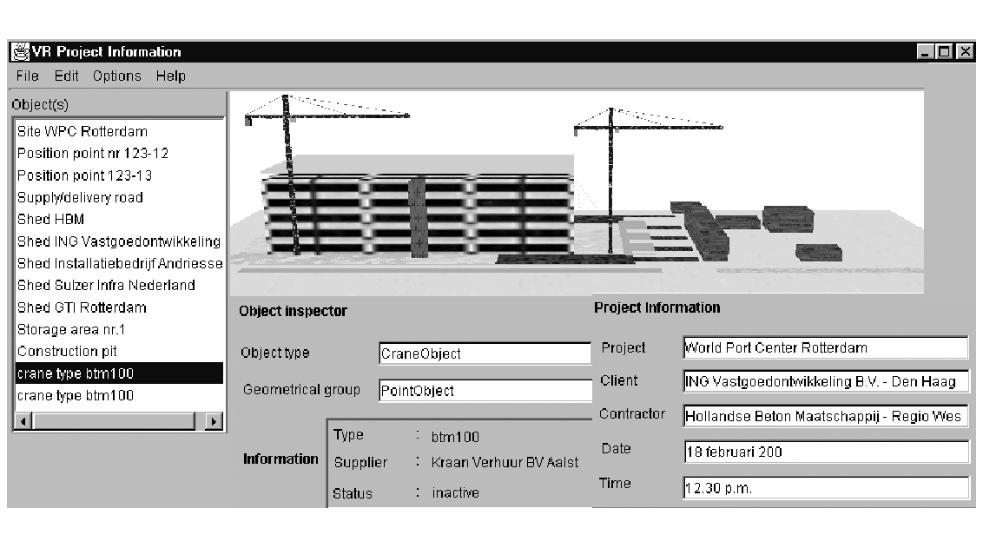
Future developments
An illustration of the ultimate envisioned VR Project Information Front-end is shown in the figure at the top of this page. The building is the World Port Centre in Rotterdam. At the point in time the reinforced concrete structure of the 6th floor (of the 24) was under construction. Two cranes and a number of sheds were used.
In the future TU-Delft will develop a working PIF for general use as part of its R&D program and make it available for free.

Conclusions
VR Project Information Front-ends will play a role of increasing importance in the European Building and Construction industry. Interactiveness is possible and security and permissions are covered by standard internet techniques.

ConCLUSIONS and recommendation
BcXML uses a LexiCon-based XML format for its data. XML's separation of content and mark-up allows both very varied visualisation and real data handling, essential for project information front-ends.
URI's, standardised data formats and the standard http protocol are what make the internet work. As the building and construction industry is too fragmented, proprietary solutions will fail, so everything must have a URI and XML and http are mandatory.
VR Project Information Front-ends will play a role of increasing importance in the European Building and Construction industry. Interactiveness is possible and security and permissions are covered by standard internet techniques.
A lot of the needed components are in place and what is missing is just a matter of time and implementation. One essential item, though, could be a showstopper. Without a structured set of definitions of objects and properties no meaningful communication is possible. It is highly recommended that a Europe-wide effort is made to fill the LexiCon. This should be a priority both for the EU and for the national governments.
REFERENCES
Fielding, R. T. 2000. Architectural styles and the design of network-based software architectures. Irvine: University of California
Lee, T. B. 2001. Semantic web activity statement. On-line at http://www.w3.org/2001/sw/Activity.
Prescod, P 2002. REST and the real world. On-line at http://www.xml.com/lpt/a/2002/02/20/rest.html.
Rees, R. van 2002. How bcXML handles construction semantics. Aarhus: CIB w78 2002 conference proceedings.
Tolman, F. 2001. Econstruct: expectations, solutions and results. On-line at http://www.ITcon.org/2001/13.

