SEMANTIC WEB TECHNOLOGIES APPLIED TO BUILDING SPECIFICATIONS
Section: T6S7 Information technology in construction
Authors: Reinout van Rees and Frits Tolman
Abstract:
The question considered in this paper is whether the application of semantic web technologies provides a good fit for future generations of computer applications involving building specifications. The discussion of this question is spaced out in three parts: a) the nature of specifications, b) the architectural principles of the semantic web and c) the “fit” of the semantic web's architecture to the nature of specifications.
There are three important aspects of building specifications. First the content of the specifications. What information is contained in a specification? Second, the goal of specifications. What does a specification intent to achieve, what are the fields of application? Third, the interaction points with the environment of a specification. The information in a specification is used by other applications. Other applications also provide information to the specification. These interactions could benefit from a more semantic link.
An ontology is a formal way of describing the set of concepts used in a certain field, from a certain viewpoint. Ontologies and the information that uses them can be accessed and exchanged in the familiar open and standardised way using the Internet. This semantic web allows you to make explicit statements and explicit links about (and in) Internet-accessible resources using ontologies as loosely-coupled, expandable vocabularies. This greatly enhances the semantic richness of Internet-based information exchange.
The example illustrates that the semantic web can provide the means by which the building specification can gain real semantic links to other documents and programs and vice versa. Also it shows that open source software is well-suited to this kind of task. The semantic web helps building specifications to become “eSpecs” and to re-assert their role as a central building document.

SEMANTIC WEB TECHNOLOGIES APPLIED TO BUILDING SPECIFICATIONS
Reinout van Rees and Frits Tolman

Abstract
The question considered in this paper is whether the application of semantic web technologies provides a good fit for future generations of computer applications involving building specifications. The discussion of this question is spaced out in three parts: a) the nature of specifications, b) the architectural principles of the semantic web and c) the “fit” of the semantic web's architecture to the nature of specifications.
There are three important aspects of building specifications. First the content of the specifications. What information is contained in a specification? Second, the goal of specifications. What does a specification intent to achieve, what are the fields of application? Third, the interaction points with the environment of a specification. The information in a specification is used by other applications. Other applications also provide information to the specification. These interactions could benefit from a more semantic link.
An ontology is a formal way of describing the set of concepts used in a certain field, from a certain viewpoint. Ontologies and the information that uses them can be accessed and exchanged in the familiar open and standardised way using the Internet. This semantic web allows you to make explicit statements and explicit links about (and in) Internet-accessible resources using ontologies as loosely-coupled, expandable vocabularies. This greatly enhances the semantic richness of Internet-based information exchange.
The example illustrates that the semantic web can provide the means by which the building specification can gain real semantic links to other documents and programs and vice versa. Also it shows that open source software is well-suited to this kind of task. The semantic web helps building specifications to become “eSpecs” and to re-assert their role as a central building document.

Introduction
The objective of the research discussed in this paper is to look into the future of the building and construction industry from the perspective of specifications. Current textual specifications will be replaced by “eSpecs”, which will be accessible both by humans and to computers. This is done (1) by applying XML technology to separate the specifications content from its mark up, and (2) by expressing the content using the terms and structure made explicit in an Internet-based ontology (“set of definitions and terms”). The research focuses on the best way to create eSpecs, and on the different ways eSpecs may be used. This paper mainly discusses implementation matters.
The paper is structured in five sections:
- Nature of building specifications.
- Nature of the semantic web.
- Implementation notes: Zope/Python.
- Architecture.
- Conclusion.

Nature of building specifications
A building specification is a central document in a building process. It, traditionally, sits between the design phase and the actual construction phase. A specification consists of both the specification drawings and the specification text. This paper mainly focusses on the content of a specification text.

Content of specifications
An essential first point regarding specifications is that it is a specification, not an explanation. That is, it is meant to be specific descriptive or prescriptive, not some loose indication.
Essential properties of the specification text are:
- The formal description.
- (References to) conditions and regulations.
- A classification.
- References to the specification drawings.
Figure 1: Specification text, connected. Cost estimation and recipes are examples of applications that want to connect to the specification text.

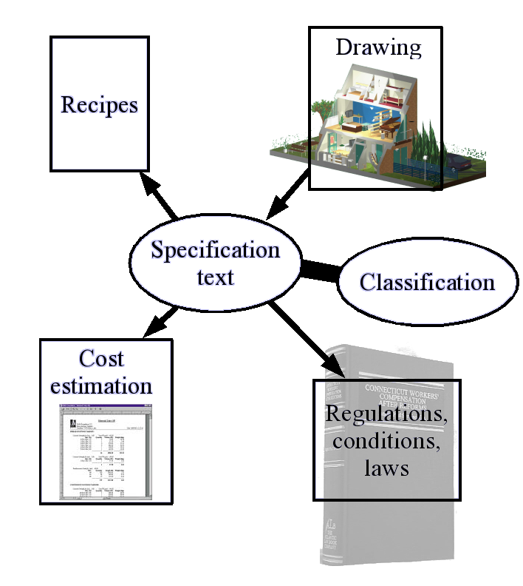
Formal description
The formal specification is build-up from a list of specification items. Historically, one specification item often deals with something that has to be budgeted. For such an item, for instance the required end result, the required quality and the source material is described.
The data behind the specification items would be the natural domain of product modelling. This data would greatly benefit from a good coupling with the drawings.

Conditions
Conditions (or regulations) give extra information on top of the plain technical data (like fire resistance = 30min). Conditions can be technical or administrative and standard or additional.
The standard (technical or administrative) conditions are typically valid for every building project. Standard administrative texts make sure that contract-wise a lot of commonly used safeguards are included. The correct terminology is used to invoke protection under certain laws. This way, what needs to be said is said simply by including it automatically in the specification. Typically, the standard conditions are available pre-printed in book form and simply included with the rest of the specification.
The additional administrative conditions describe the administrative conditions that are specific to this project. Delivery time, payment agreements, steering of the project. The additional technical conditions describe things like delivery of samples for the client to agree upon, etcetera.
A good semantic link would be beneficial. That way, an application could help you deal with certain building regulations, offering advise for instance.

Specification structure: classification
One common way of subdividing the textual specification is subdivision into parts called chapters. Traditionally the chapters often correspond with branches of the industry or kinds of work. All the paintwork is in one chapter, the groundwork in another and the doors & windows in a third. This makes it easier to provide a cost estimation by allowing the different experts to estimate their part. This kind of subdivision is common in the housing and utility construction section, traditionally subdivided in specific crafts.
On the down side, much information gets scattered all over the place when there are specification items that impact more than one kind of work.
The structure is normally a classification (a subdivision in classes and subclasses, with the subdivision being done according to a specific view, to make it comfortable to be used by humans (Van Rees 2003)).
A second common way of subdividing is by following normal execution patterns. The reason for this is that detailed cost estimations (in the ground/water/road sector) are normally made that way. A good match between the cost estimation and the specification text is desired.
The specification classification is sometimes also used to structure other information. Links, made that way, are however on the chapter/section/subsection level, not really on the level of the actual specification units.

References to the specification drawings
Normally, the references to the accompanying specification drawings are not extensive. The “doors on the ground floor” are described. Also you can describe a set of doors, mentioning “placement according to drawing”. These references are all textual.
A better coupling with the drawings will be a big advantage to the building industry. There are some possibilities to generate a partial specification from well-executed drawings, but even then there is no real two-way link.

Nature of the semantic web
The web allows us to access a vast hoard of information. You search in google almost before you ask a colleague for information, so the web is already firmly in place. The semantic web is a set of technologies that allows computer programs an equivalent richness of information.
Figure 2: Almost asking google before asking colleagues..
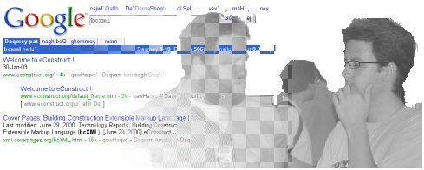

Related research in the building industry
In order to be able to place the contents of this section in its proper perspective, we briefly show the work done in two recent EU-funded projects: eConstruct and e-cognos.
The goal of eConstruct (http://www.econstruct.org/) was to harness the possibilities of the Internet for the building industry, concentrating on the communication in the buying and selling phase. Conceptually, three things are needed for communication: a vocabulary, a grammar and a communication medium (Van Rees et al. 2001).
- A taxonomy (sporting a specialisation hierarchy, property definitions and multi-linguality) was used as the vocabulary of terms. The iso/dis 12006-3 developments were used for this.
- The grammar (data format) was bcxml, a custom xml format. Basically it used the terms of the vocabulary, allowing for an intuitive and human-friendly <Window height=”2.40” unit=”m”/>-like language.
- The communication medium was the Internet, used to connect a few services (catalogue server, taxonomy server, etc.).
E-cognos (http://www.e-cognos.org/) started the moment eConstruct finished and took the development into the direction of knowledge management. Harnessing the existing and available, but not well-findable, knowledge contained in documents and in people.
- Multiple cooperating ontologies (footnote: e-cognos used the term ontology instead of taxonomy; they stressed most the specialisation hierarchy and the rich functionality for synonyms etc.) provided multiple cooperative ways to access and find and classify information.
- Data was exchanged in xml (partly re-using bcxml) and in rdf (combined with daml+oil), which is an xml format for ontologies and ontology-based data.
- The Internet was, like in eConstruct, used to access the ontologies' information. But the big innovation was to add the information richness allowed by the ontologies onto existing information contained in document management systems and employee databases. Superimposing ontological richness onto existing systems proved possible.
Both projects achieved good results, allowing us to suggest the following as best practice:
- Store definitions of terms, vocabularies, etc. in widely accessible ontologies. This way, the terminology used is made explicit. Explicit is better than implicit.
- Use xml, or the more specific rdf, for information exchange.
- Use the internet as the basic communication medium.
Figure 3: E-cognos search interface showing the link with the ontology (broader/narrower terms). The user interface is made with Zope/Plone.
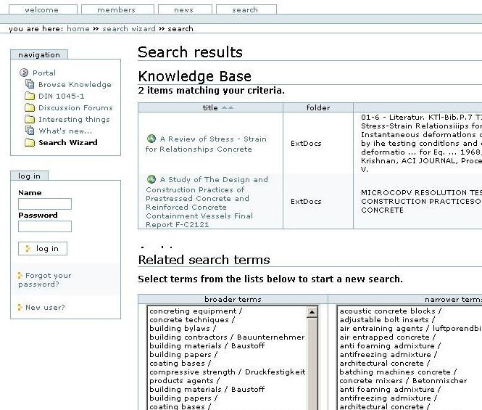

Webify data
Webifying data means that every piece of useful data should have a URI. The success of the World Wide Web is entirely based on assigning a URI to every single webpage and image and enabling links between them (Prescod 2002).
Webifying a door catalogue, for example, in this case doesn't mean having one human-readable page containing pictures and some text listing the available types. It means having your catalogue available at http://compagny.co.uk/doorcatalogue and the parts describing the various individual doors at http://compagny.co.uk/doorcatalogue/door1 etc. This makes it possible to link to a specific door in you catalogue from the project where they want to use your door.
URI's, standardised data formats and the standard http protocol are what make the internet work. As the building and construction industry is too fragmented, proprietary solutions will fail, so everything must have a URI; and XML and http are mandatory. (Van Rees et al. 2002)
Figure 4: Terminology and structure made explicit in ontologies; data using those ontologies; everything accessible using the Internet.
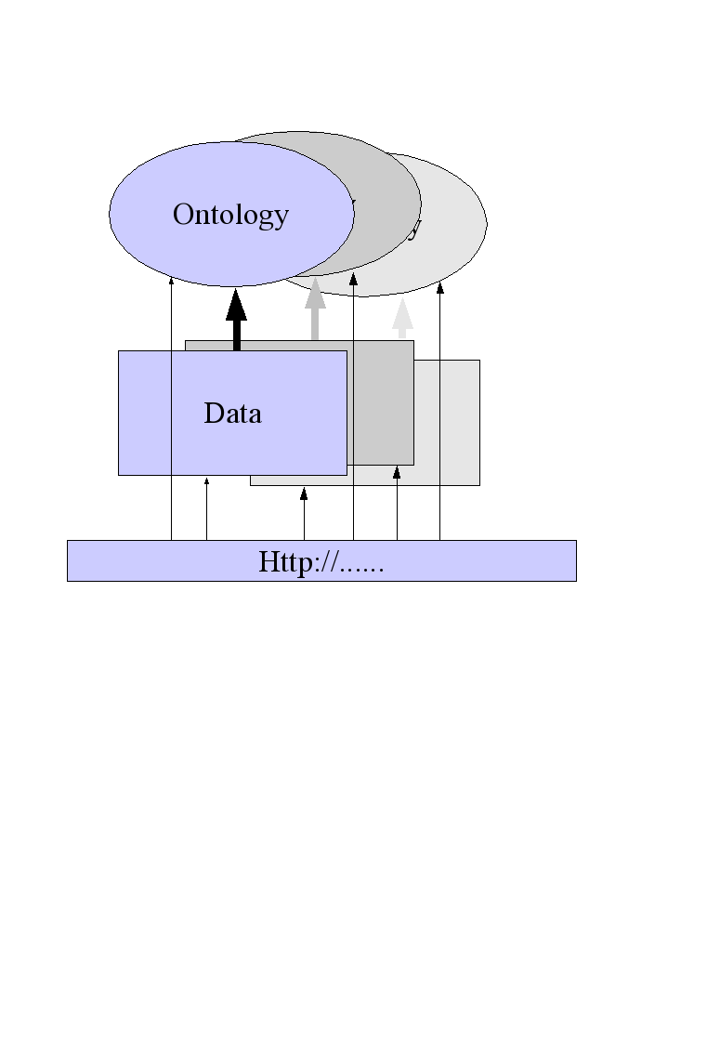

Ontology language
Webifying data is the first necessary step to enabling the semantic web for the building and construction industry.
A second step is by using a standard data format for shareable ontologies (http://www.w3.org/2001/sw/): RDF (and its more powerful add-on, OWL). OWL provides us with a way of dealing with:
- Classes and properties and their relations.
- Subtype hierarchy (both for classes and for properties).
- Textual information (labels and descriptions, multilingual).
- Re-using classes and properties from other ontologies, allowing you to build on previous work and to use more generic high-level ontologies as a common basis for two ontologies that need to exchange information.

Implementation notes: Zope/Python.
When implementing a semantic web solution, two main components have to be available:
- A web application server, providing a web server and a programmatic framework to drive it. A popular choice in the research community seems to be apache’s tomcat java web application server (http://jakarta.apache.org/tomcat/).
- A semantic data store, providing a means to store and query RDF files. A popular choice is Hewlett-Packard’s jena (http://www.hpl.hp.com/semweb/jena.htm).
The main goal is to store and query RDF and to provide an internet user interface which interacts programmatically with the rdf store.

Development speed and ease-of-use
Python and Zope are attractive for web programming. Python (http://python.org/) is a high level (scripting) language which is regarded by most as both elegant and powerfull, suitable for programs both big and small. It is platform-independent (windows, unix, mac; recent versions of mac OSX even ship it as part of the operating system).
Zope (http://zope.org/) is a web application server (written in Python) with a lot of built-in extra's:
- Built-in object database.
- User management and flexible password protection.
- Through-the-web management interface. No need for changing files on the filesystem.

Reusable modules
Both Python and Zope have a big community that creates a lot of add-ons and modules that - most of them are open source - can be freely reused ("free" meaning both freedom to change and re-distribute and free of charge). There are two main modules that form the basis of the implementation of this research.
- Rdflib (http://rdflib.net/).
A simple rdf store that parses, stores, queries and exports rdf files. To store and query big data sets you can use Zope’s object database that can handle big data sets efficiently.
- Plone (http://plone.org/).
An attractive (but changeable) user interface on top of Zope’s. With little effort a great result can be obtained (ideal for a time-strapped researcher). Recently, the possibility to generate web forms from UML diagrams added even more attractiveness to this solution.
We created a version of rdflib that could be used within Zope and Plone, allowing us to quickly develop an attractive web-based user interface to an rdf model.

Architecture
Basic property of the architecture is to cater for exchange of information between different sources of information, each with its own goal, its own methods, its own peculiarities.

Ontologies
Each information source has its own view of the information. Such a view can be formally and explicitly described in an ontology. An ontology is a formal way of describing the set of concepts used in a certain field, from a certain viewpoint.
This means that, to describe the field of specifications and the terms used therein, a specification ontology could capture the concepts used to create specifications (chapters, specification units, regulation references), but also the concepts that form the actual contents of the specification (masonry, double glazed windows). Likewise for a cost estimation ontology. Or an ontology that makes explicit the terminology for creating window frames.
Also there could be a generic ontology (probably multiple) that describes a reasonable amount of generic terms. Above example of the specification ontology and the cost estimation ontology shows that the same field (buildings for instance) can be described from two different viewpoints. Doing partly the same work twice (and probably not-too-compatible) could be prevented by using a joint, generic, ontology for the parts that overlap. A generic ontology could for instance include windows, but not double glazed windows. Existing classification systems could fill part of the bill, though adaption to the newer possibilities of ontologies might spark an effort to create new versions.
A generic ontology could be made more specific by branch-specific or application-specific ontologies. Application ontologies add the concepts needed for cost estimation, for instance, or for fire safety calculations. Branch ontologies further specify and add concepts from their branch of the construction industry. The generic ontology won't include the 70+ properties needed for precise description of every nook, cranny, hole, etcetera in a window frame. A specific ontology for the window-making industry will.
The emerging picture here is that of multiple ontologies that cooperate to a bigger or lesser degree. The base requirement is that some branches of industry and/or some applications and/or some existing classification systems make their vocabulary, their set of concepts explicit in an ontology.
By cooperating and re-using work already done in other ontologies, a web of ontologies (or ontology web) can come into being. OWL (the web ontology language, building on RDF) has built-in support for cooperating ontologies.
Figure 5: Data using ontologies. Ontologies storing the explicit terminology and structure used by the data. Ontologies interconnected and cooperating. Everything accessible using the Internet.

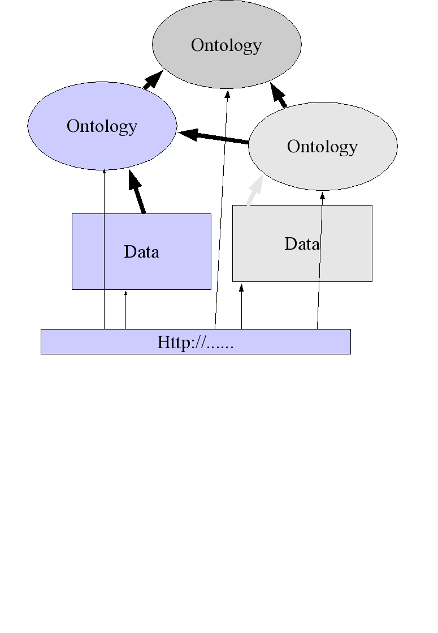
Information sources
What is presented in this section and the next is just one way of looking at the information sources, but it serves to illustrate the point.
When looking at a building project, you can distinguish four kinds of information in two dimensions. The first dimension is whether the information is specific to the project or not. The second dimension is whether the information is specific to a certain company or not.
Not project-specific and not company-specific is the generic information. Building codes, for example.
Project-specific is the project information. The not-company-specific part of this includes the client's brief, govenment's plans regarding this project, the building specification, etc.
Company-specific is the proprietary information. The not-project-specific part includes internal regulations, internal recipes-for-work, a database of past projects, etc.
The proprietary information and the project information overlap partly. This is an area where problems loom. Part of the proprietary information could be very handy for the project and therefore for the project partners. But do you want to give them that valuable information for free? Do you want to share it? It might be a competetive advantage in later projects, which you give away by sharing.
Also, part of the project information will be necessary for the company. The specification drawings, the specification text, etc. Essential for coupling with the internal information like work planning. But the project information has to be available to all partners in the project. This therefore means that the information has to be shared, so it either has to be kept in one location or different copies have to be kept synchronised.
The essential property here is that the information has to be shared between the quadrants. The information should at least be partly accessible.

Example
As an example, let us take the project description, as made by the initiator of the project. When taking the semantic web route, this should be available over the Internet and its concepts should be described in an ontology. It includes links to the textual specification, for instance.
Figure 6: Screenshot showing the specification information for masonry. Quality is a reference to a norm, information where to find that norm is included in the specification.
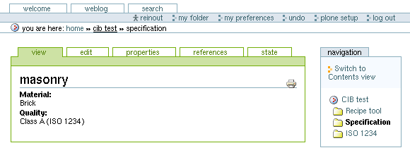
Figure 7: Simple visualisation of the norm. This is also available in a computer-readable semantic web format, so the recipe tool can read this, too.
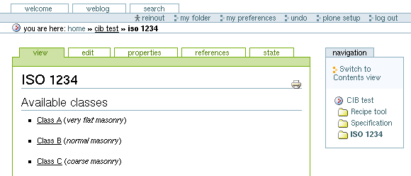
Secondly, we take internal company data. A set of recipes on a generic level, containing data on how proficient the company is in executing certain projects. These recipes also include the information needed to automatically calculate an initial value for the cost associated with such a project.
In the third step, a company-internal web crawler visits well-known sites which list project that are currently waiting for a contractor. It downloads the project descriptions and, by using the information in the project ontology and in the recipe ontology, tries to figure out the attractiveness of the projects and calculates a first-cut estimate of the project costs.

Figure 8: The recipe tool collects the applicable information. It has a recipe entry dealing with ISO 1234, indicating that for this part, the pricing isn't competitive.
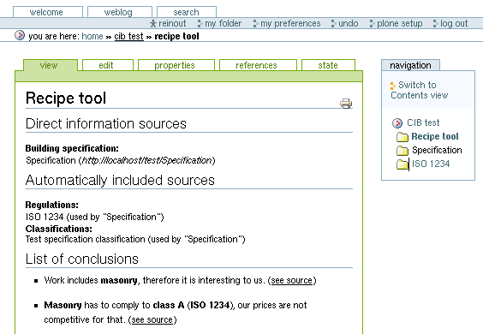

Conclusion
For many years building specifications (especially the textual specification) have had a central place in the building process, traditionally situated between the design phase and the actual construction phase. Specifications have links with other documents in the building process like regulations and calculations. The links are, however, mostly only human-readable links. There is very little a computer can do automatically. Specifications would gain from a real semantic link.
To be able to create and apply eSpecs, it is of course necessary to use the Internet as the communication medium. Secondly, the definitions of terms, vocabularies, etcetera have to be made explicit in accessible ontologies. Multiple cooperating ontologies can form an ontology web. These ontologies and the data that uses them ideally should be communicated using XML and RDF/OWL over the Internet: the semantic web.
The example illustrates that the semantic web can provide the means by which the building specification can gain real semantic links to other documents and programs and vice versa. Also it shows that open source software is well-suited to this kind of task. The semantic web helps building specifications to become “eSpecs” and to re-assert their role as a central building document.

References
Prescod, P. 2002. Second Generation Web Services. http://webservices.xml.com/pub/a/ws/2002/02/06/rest.html
Van Rees, R., Tolman, F., Lima, C., Fies, B., Fleuren, J., Zarli, A. 2001. The Econstruct Project. Ebusiness and Ework. Amsterdam: IOS press.
Van Rees, R., Behesthi, R., Tolman, F. bcXML enabled VR project information front-ends. Ework and ebusiness in architecture, engineering and construction. Lisse: Balkema.
Van Rees, R. 2003. Clarity in the Usage of the Terms Ontology, Taxonomy and Classification. Proceedings of the 2003 cib w78 conference. Auckland.

Bibliography
Zijlstra, J.O. 1987. Bestekken in de grond-, water- en wegenbouw. Ede: CROW.
Gelder, J. 1995. Specifying buildings – a guide to best practice. Milsons Point: Natspec.

Reinout van Rees is a PhD student at the department of Civil Engineering and Geosciences, Technical University Delft, the Netherlands; he also works at Stabu Foundation, Ede, the Netherlands.
Frits Tolman is professor at the department of Civil Engineering and Geosciences, Technical University Delft, the Netherlands.
Comment taken from e-cognos final meeting, see http://vanrees.org/ecognosmeeting.

