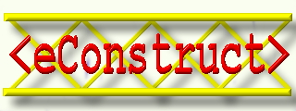

IST-1999-10303

D501
bcTaxonomy

Authors:
Kees Woestenenk STABU
Reinout van Rees STABU/TUD

Distribution | Draft1 | Draft 3 | Issued 4
Date | 3-12-01 | 3-01-02 | 08-01-02
BETANET | *
CSTB | *
EPM | *
NEM | *
STABU | *
TNO | *
TUD | *
TW | *
WWW
CEC
Deliverable Reference
WP  WP5 | Task  T5100 | No.  D501
Status Draft/Issued/Revised  Issued |  | Rev.  7
Date  8-01-2002 |  | Release to CEC  -
Document Control Sheet

Revision | Status | Page Nos. | Amendment | Date | By
1 | Draft |  | First version | 03-12-2001 | STABU
2 | Draft |  | Added software description |  | STABU
3 | Draft |  | Comments from TW | 03-01-2002 | TW
7 | Issued |  | Final version | 04-01-2002 | STABU

Table of Contents
1 Introduction 4
1.1 Summary 4
1.2 Structure of the document 4
1.3 Credits 4
2 The content of the LexiCon 5
2.1 Historical background 5
2.2 Concepts in the LexiCon 5
2.2.1 Definition 5
2.2.2 Specialization 7
2.2.3 Composition 7
2.2.4 Properties 7
2.2.5 Collections 7
2.2.6 Names and descriptions 8
2.3 LexiCon content developed before eConstruct 8
2.4 LexiCon content developed for eConstruct 8
2.5 Future content development 10
3 Rules for determining the hierarchical structure of the LexiCon content 11
3.1 Subjects 11
3.2 Activities 12
3.3 Collections 12
3.4 Properties 13
3.5 Measures 14
3.6 Units 14
4 Criteria for the hierarchies 15
5 LexiCon convertor documentation 16
5.1 Transferring LexiCon content to bcTaxonomy 16
5.1.1 Structure of the LexiCon contents 18
5.1.2 Structure of the bcTaxonomy 18
5.1.3 Main mappings between the LexiCon and bcTaxonomy structures 18
5.2 Using the LexiCon convertor 19
5.2.1 Obtaining the software 19
5.2.2 Exporting XML from the LexiCon explorer 19
5.2.3 Using the convertor 19
5.2.4 Future maintenance and adaption 19
6 Taxonomyserver documentation 21
6.1 Introduction 21
6.2 Technical architecture of the taxonomy server 22
6.2.1 The taxonomy 22
6.2.2 SOAP interface 22
6.2.3 HTML interface 22
6.2.4 Summary 23
6.3 Using the taxonomy server 23
6.3.1 Obtaining the binary distribution 23
6.3.2 Installing tomcat 23
6.3.3 Installing the taxonomyserver 23
6.3.4 Using the web interface 24
6.3.5 Obtaining the source code 26
7 References 27

Introduction

Summary

Stabu foundation is undertaking the building of a taxonomy for the building and construction industry called the LexiCon. This is done in co-operation with, amongst others, the eConstruct project.
The bcBuildingDefinitions taxonomy is a freely available version, mainly build for (and in) the eConstruct project. It is expected for the complete taxonomy to take 50 man years to complete.
To fill the taxonomy, Stabu uses the LexiCon Explorer, which was extended with an XML-export module during the project. The exported file (containing all the taxonomy data) can be converted (using the lexiconconvertor) to the XTD taxonomy-format used by eConstruct.
The converted taxonomy is the one called bcBuildingdefinitions. In order for other software developed within the project to access the taxonomy information, a taxonomyserver was made, fitting within eConstruct’s reference architecture.

Structure of the document

The various items mentioned above are all discussed in greater detail in this document
This document introduces the LexiCon taxonomy and the programs developed within eConstruct that accompany it.
Chapter 2 discusses the structure and content of the LexiCon. Chapters 3 and 4 explain the hierarchy chosen in the LexiCon and the rationale behind it.
Chapters 5 and 6 describe the convertor program that converts the LexiCon taxonomy to the format chosen by eConstruct and the eConstruct taxonomyserver that provides the access to the taxonomy within eConstruct.

Credits
Within the scope of the eConstruct project, the Stabu Foundation (especially Kees Woestenenk) has developed the LexiCon structure and content. Taylor Woodrow Construction (Jeff Stephens) has helped greatly with the required catalogue data.
The convertor and the taxonomyserver have been made by Stabu (Reinout van Rees). The converter would be nowhere without the perfect bug reports by TNO (Peter Bonsma). The taxonomyserver has received help and feedback from CSTB (Celson Lima) and TUD (Reinout van Rees).

The content of the LexiCon

Historical background
For several years ISO TC59/SC13 has been working on the standard ISO 12006 Organization of information about construction works. This standard now consists of two parts: Part 2: Framework for classification of information, and Part 3: Framework for object-oriented information exchange. Part 2, prepared by WG2, has been sent to the ISO Central Secretariat for formal vote (FDIS), and Part 3, prepared by WG6, is published as a Publicly Available Specification (PAS) [isopas].
Part 3 describes a formal information model for a framework for a common terminology about objects and their attributes that are of interest for the construction industry. The framework provides for:
- the definition of concepts;
- the definition of relations between concepts;
- the naming of concepts (with multi-lingual capacity).
In the object-oriented approach, taken in Part 3, the object is central, acting as a container of characteristics. This approach, also known as ‘product modelling’, is similar to those taken in other standards, such as the ISO STEP series (ISO 10303), EPISTLE (ISO 15926) and the Industry Foundation Classes (IFC) published by the Industry Alliance of Interoperability (IAI). To harmonize between these standards as far as the construction industry is concerned, TC59/SC13 initiated the so called ‘Standing Conference’, which was held for the first time in Vancouver, June 1999, and lastly in Oslo, December 2000. In the realm of ISO STEP and EPISTLE there are two so called ‘object libraries’: STEPLib and the EPISTLE Data Reference Library, which are being harmonized. Both these libraries are in the field of the process and off-shore industry. These libraries have some overlap with the construction industry. The IFC are in the field of the construction industry. Part of the IFC are the so called ‘Property Sets’, providing definitions similar to those defined in the framework of ISO PAS 12006-3.
Within the eConstruct project a population of the LexiCon was needed to demonstrate the use of it. Until then STABU had filled the LexiCon with sample data. In eConstruct the LexiCon content is called a ‘taxonomy’. The eConstruct taxonomy is limited to ‘Doors’ and components of doors.
For the population of the LexiCon additional rules and guidelines are needed beyond the structure defined in ISO PAS 12006-3.

Concepts in the LexiCon

    - Definition
The Oxford Dictionary gives the following description of concept:
“concept noun an abstract idea; a general notion: structuralism is a difficult concept | the concept of justice.
A plan or intention; a conception: the centre has kept firmly to its original concept. An idea or invention to help sell or publicize a commodity: a new concept in corporate hospitality.
Philosophy: an idea or thought which corresponds to some distinct entity or class of entities, or to its essential features, or determines the application of a term (especially a predicate) and thus plays a part in the use of reason or language. [as modifier] (of a car or other vehicle) produced as an experimental model to test the viability of innovative design features.”
Concepts in the LexiCon follow the philosophical definition: an idea or thought which corresponds to some distinct entity or class of entities, or to its essential features, or determines the application of a term (especially a predicate) and thus plays a part in the use of reason or language. In ISO PAS 12006-3 it is mentioned that the framework provides:
- the definition of concepts;
- the definition of relations between concepts;
- the naming of concepts (with multi-lingual capacity);
with the following explanation:
“Real-life objects can be grouped in classes, e.g. the four walls of a given room belong to the conceptual class ‘wall’. Relations, properties, etcetera, and groups of classes can be objects as well, e.g. the size of a wall, or the U-value of a wall.”
In the LexiCon, concepts are restricted to classes of objects (or classes of entities as mentioned in the Oxford dictionary). This means that the LexiCon does not describe real-life objects or entities, but only abstractions of these in the form of classes or types. Or, following the above example from ISO PAS 12006-3, the four walls of that room are represented in the LexiCon by the class ‘wall’. The concept of the class ‘wall’ is the idea we have when we talk about a wall: what do we mean when we use the word ‘wall’.
In the LexiCon concepts are distinguished into the following main categories:
- Subjects: the objects that result from building Activities, including spaces and products
- Activities: the activities that result in or modify Subjects
- Collections: a grouping of Subjects, Activities or Properties based on a certain criterion, mostly a function or role
- Properties: characteristics or features characterizing or qualifying a Subject or an Activity, either directly or indirectly through a Property collection
- Measures: the scale used for the value of a Property
- Units: the scaling part of a Measure.
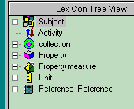
Concepts available in the LexiCon

Following ISO PAS 12006-3 a concept is formally described with the help of other concepts, although somewhere we will end with concepts described by a statement of some kind. To describe a concept using another concept, the two concepts have to be associated by assignment through a relationship. Basically the relationships can be distinguished into the following types:
- specialization
- composition
- property
- collection.

Specialization
The specialization relationship states that this concept is a specialized type of the other concept. When a concept is a type of another concept this means that this concept is similar but not equal to the other concept. This has to do with the idea of ‘class’ or ‘type’. As mentioned before the LexiCon only describes classes of objects, not the real-life objects. Real-life objects are grouped into classes based on characteristics they have in common, and by leaving out other characteristics. The other characteristics are not considered to be relevant for the class. Hence, an object is member of a class through a set of shared characteristics. The object has many more characteristics though, which means that two objects belonging to the same class of objects, can still be different. Within a group of objects belonging to a class of objects, we could make a sub-group that forms a new class. This new class could be distinguished from the main class by one ore more additional or more restrictive characteristics. This new class then is a specialization of the earlier class. It has all the characteristics of the earlier class, but it can be distinguished from that class by additional, or more restrictive characteristics. The new class is always a member of the earlier class, but the earlier class is not as specific as its derived class. The specialization relationship is also called a ‘type-of’ relationship or an ‘is-a’ relationship. Also the terms supertype and subtype are used, and in object orientation it is said that a subtype ‘inherits’ the characteristics of its supertype. Grouping classes according to specialization results in a specialization hierarchy.

Composition
The composition relationship states that this concept actually consists of a number of components. This relationship is therefore also called a ‘part-whole’ relationship. We could say, for example, that a ‘brick’ is a ‘part-of’ a ‘wall’. In this example the ‘part’ is the brick and the ‘whole’ is the wall. Put it the other way around we could say that a wall is an assembly of bricks. Both brick and wall are concepts, which does not mean that these concepts are of the same type, almost always components and assemblies are from different classes, although on the highest specialization level components and assemblies belong to the same category. For example, both wall and brick are of the category Subject. Grouping classes according to composition results in a composition hierarchy.

Properties
The property relationship states this concept can be characterized or qualified with a concept belonging to the category of Properties. The term ‘Property’ could be replaced by ‘Characteristic’ or ‘Feature’. In the LexiCon Properties can be assigned to (associated with) Subjects or Activities, either directly or indirectly through a Property collection.

Collections
In the LexiCon the collection relationship groups concepts of the same type or category, hence there are collections of subjects, collections of activities and collections of properties, as far as these collections are neither specialization nor composition relationships. In the LexiCon collections can be grouped into a collection hierarchy, which is a specialization hierarchy.

Names and descriptions
Concepts are indicated by names and descriptions. By nature these names and descriptions can be imprecise or ambiguous, they don’t follow the strict rules of a formal language. Still, this is the way humans communicate, and this is certainly true for those working in the construction industry. We speak different languages, not only between nations, but also we have our own jargon for different areas in our industry. We use synonyms and homonyms freely. If we were forced to use a formal language this would not work. The solution of ISO PAS 12006-3 and the LexiCon to this dilemma is to define concepts formally on the one hand, and assign names and descriptions in any language or jargon on the other. As long as the concepts are uniquely identified, we are free to use any name or description that we regard as applicable, without concern about the uniqueness of a name or description. In the eConstruct project, the LexiCon has implemented a limited number of languages (English, Dutch, Norwegian, German, French, Greek), of which English is considered as the one common international language. This is to help finding out whether the terms assigned to a certain concept really apply. Unlike dictionaries where words are translated, we have to be sure that the words are in accordance with the concept they point to.
In addition to lexical names and descriptions the LexiCon also allows the use of images, although this is not yet fully implemented.

LexiCon content developed before eConstruct
The first version of LexiCon Explorer dates from 1995. This and following versions were used to provide content to the LexiCon, which should be considered as trial implementations for discussion. However, a lot of this early input still applies. Amongst this content are the complete SI system (ISO 31) and a detailed list of external documents. External documents are sources of information, such as national and international standards, as well as classification systems, such as EPIC. The LexiCon not only contains the titles of those documents, but also parts (especially definitions) from these documents, which can be linked to the actual content of the LexiCon.

LexiCon content developed for eConstruct
The objects of interest that are supported are as follows (illustrated with screenshots from the LexiCon:

- doors
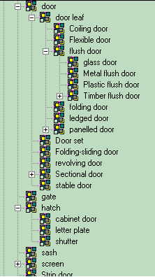
Hierarchy showing the door subjects

- Precast concrete edge beams
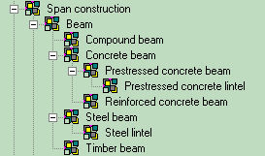
Hierarchy showing concrete beams
`
More items than this have been added, though. Hinge, letterbox, etcetera. Above items, however, are the ones that are complete. If time permits, we will add in much more detail hinges and handles of the ironmongery group and possibly tiles.
All content is placed in an ad hoc specialization hierarchy. As discussed below, this hierarchy was set up intuitively, implying some inconsistency. This inconsistency, however, has no influence on the data attached to the entities, because of the inheritance mechanism which guarantees that each entity has always a complete set of defining data.
As reference documents the complete contents of the British Glossary of Building and Civil Engineering terms were added, as well as the headings of Uniclass classification system (UK), Masterformat (US) and the Dutch Elementenmethode. In addition references were made to European and national standards with respect to the entities added to the LexiCon.

Future content development
STABU will continue developing content for the LexiCon, possibly in cooperation with other organizations. In the Netherlands, content development will be done as a national project, within the BAS organization, consisting of all professional information providers in the Netherlands. Existing libraries of electro technical and mechanical products, developed by the Dutch electro technical and mechanical contractors organizations UNETO and VNI, will be merged into the LexiCon, and a cooperation is established with CROW for the development of content for civil engineering.
Internationally, the development of the LexiCon is supported by the members of the International Construction Information Society (ICIS). Through ISO TC 59/SC13 and the Standing Conference (see Historical background) attempts are made to synchronize the LexiCon content with the International Foundation Classes (IFC) developed by the International Alliance of Interoperability (IAI).
As a guide for further development a handbook is under development. This handbook will also contain the rules for determining the hierarchical structure of the LexiCon content, as discussed in the thirth chapter.

Rules for determining the hierarchical structure of the LexiCon content

Subjects
ISO PAS 12006-3 defines a Subject (LexSubject) as “anything that can exist. A LexSubject can be a physical thing or a logical thing.” In the LexiCon Subjects are interpreted as the objects that result from building Activities, including spaces and products.
From a conceptual point of view it is not necessary to distinguish between products and buildings or parts of buildings. A building can be regarded a product and a product is a potential part of a building, hence the difference is not conceptual, but has more to do with status or state of life. Whereas most classification systems have different tables for building types, spaces, elements and products the Subjects of the LexiCon comprises them all in a single hierarchy.
Finding a satisfactory specialization hierarchy for Subjects appears to be very difficult. First of all, many different hierarchies are possible, and using multiple inheritance (that is using multiple hierarchies) is not possible in the current version of the LexiCon. Building a consistent hierarchy requires the use of specialization criteria. A specialization criterion can be found in a composition relationship or in a Property or Collection assignment. We found that it makes sense to distinguish Subjects into Functional concepts and Technical concepts. This distinction is an elaboration of Gielingh’s GARM [garm]. A Functional concept is completely abstract, such a Subject is described by its behaviour or role it is supposed to fulfil. In classification terms such Subjects are called Elements (although Elements are restricted to functional parts of buildings). Technical concepts describe the structure of a Subject, hence its components. The fact that Technical concepts have the functionality of the Functional concepts make them specializations of Functional concepts. Applying this principle to the specialization hierarchy in the LexiCon population as developed for the eConstruct project, resulted in a hierarchy of alternating levels of Functional and Technical concepts. On the highest level below Subject we have now amongst others: ‘Space’, ‘Construction’, ‘Installation’ and ‘Material’. Looking at these Subjects from a functional point of view leads to the following table:

Space | Accommodation function
Construction | Structural function
Installation | Service function
Material | Undefined function

‘Undefined function’ for Material means that the function is not yet known, at least cannot be used as a distinction. The other three functions are basically distinctive. The main function for Spaces is to provide accommodation for user activities. Constructions are the physical objects that can resist forces, and Installations are capable to convert energy in some action. It could very well be that we will find other basic types on this level, in which case we can add a node to the tree. As a matter of fact, the LexiCon had three other Subjects defined on this level: ‘Terrain’, ‘Face’ and ‘Subject collection’. Terrain stands for natural objects that are already there, which is in principle the surface of the earth with all things growing on that. Terrain could be interpreted as a kind of Construction, in which case it could be grouped under Construction, either as a separate type or intermingled with man-made Constructions. With Face we mean the faces of shapes, and maybe Shape could be a higher level of Face. Faces and Shapes are abstract objects with their own set of characteristics, but which cannot be associated with functions. From this we might conclude that Faces and Shapes are not Subject at all, in which case they have to move to Properties or Property collections (in fact Shape was already part of Property collections) and that causes its own problems. Interpreting Face or Shape as a Property causes a problem, because Properties cannot have Properties, whereas Faces and Shapes do have Properties. Hence Property collections could be used. Subject collections, finally, are groupings of Subjects not based on a common function, but instead on another Aspect. Ironmongery for example, is a grouping of all kinds of hardware used with doors and windows, but the individual members of this group have totally different functions.
The above discussion demonstrates the difficulty of using a single characteristic on a certain level in the specialization hierarchy. We find similar difficulties on other levels as well. In addition we find that the suggested alternation between Functional concepts and Technical concepts is not straightforward as well. Sometimes we go through several levels of Functional concepts, before changing to Technical concepts. For example, if we go into Construction, we have Separation construction as a sublevel. Under Separation construction we find Access construction and under Access construction we find Door. All of these are still Functional concepts. The first Technical concept we find on a sublevel of Door, where we have Door set, which is an assembly. On the same level as Door set we also have Door leaf, which is a Functional concept again. So we even have Functional concepts and Technical concepts on the same level.
The only rule that can be extracted from this is that the specialization hierarchy of Subjects is first of all based on a functional distinction, and that Technical concepts should always be a specialization of a Functional concept.

Activities
Activities are the activities that result in or modify Subjects. We suspect that Activities follow more or less the same reasoning as with Subjects, but we have not investigated that yet in detail.

Collections
Collections are groupings of Subjects, Activities or Properties based on a certain criterion, mostly a function or role. In the eConstruct project Collections were initially limited to Property collections. A Property collection consists of a set of Properties. A Property can be a member of multiple Property collections. Because several Property collections can be associated with a single Subject, a Property might occur indirectly more than once as a Property of a Subject, be it in different contexts. Logically this can be correct. In practice, however, it could be confusing to see several occurrences of the same Property describing a Subject with different values. In such a case, the rule would be that the highest Value would apply.
A Property collection has its own specialization hierarchy. In the eConstruct LexiCon population we have Function and Load on the highest levels, and – provisionally – also two others: Shape and Durability, both of which don’t have any descendants yet. As long as Function is one of the major specialization criteria in the Subject hierarchy, it can be expected that Function specialization and Subject specialization are much in parallel with each other.
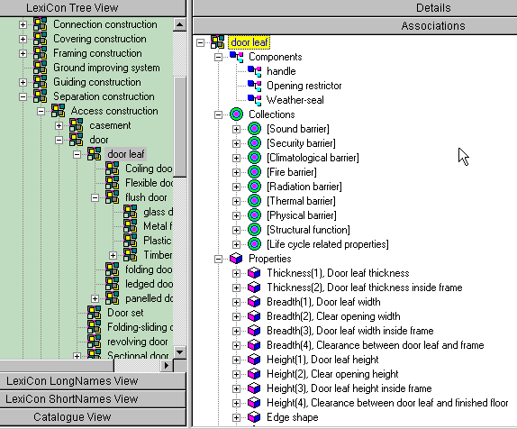
Load as a Property collection seems somewhat strange. It can be argued that Load is not really something that can be owned by a Subject or Activity, unless such a Load is evoked by that Subject or Activity. The idea of Load here, however, is not an evoked Load, but a Load that acts upon the Subject or Activity. From the point of view of the receiving Subject or Activity it might not be necessary to know the origin of the Load, it is something coming out of the environment that has to be dealt with. The fact that Load implies some reactivity (action = reaction) from the Subject or Activity makes it acceptable as a Property or Property collection.
LexiCon showing components, property collections and properties for “door leaf”

Properties
Properties are characteristics or features characterizing or qualifying a Subject or an Activity, either directly or indirectly through a Collection. Basically, a Property is a data container, the data being called the Value, and measured by a Unit. Property as a type (or class) defines the meaning or semantics of the data (the Value) in the container.
A large number of Properties can be found as Quantities in the SI system (ISO 31). These are well defined and they have associated Units to express the Value of the Property, but they are restricted to Quantities to be used in mathematical expressions. The set of SI Quantities has hardly any specialization, although ISO 31 is divided in several parts, covering different areas of interest. These different areas could be used for specialization. Another distinction might be between intrinsic Properties, like ‘mass’ and ‘length’, and extrinsic Properties, such as performances (e.g. ‘strength’) and loads (e.g. ‘static load’).
In the eConstruct population of the LexiCon we have also a specialization hierarchy of Properties. On the highest level we find Constituent material and Feature next to Quantity. We also separated Performance from Quantity, although the SI system treats Performance as a Quantity. Treating Constituent material as a Property makes sense, although it could be argued that material – as a group of molecules – basically belongs to the category of Subjects, where each type of material is characterized by its own set of Properties. On the other hand, in many cases it suffices to specify only the names of the material, instead of going into the deep by associating all kinds of molecular Properties.
Features are characteristics that don’t fit into any of the other Property categories. We have for example Shape features, such as Edge shape, Treatment features, such as Surface treatment, and Features that describe Moving types, or a Feature that makes the distinction between internal and external locations.

Measures
Measures are the scales used for the value of a Property. Measures are a proposed extension to ISO PAS 12006-3. A Property is quantified by a Value, and that Value is measured using a Unit. For example, the Value of a Length is measured in metres, according to the SI system. We can also use the inch as a Unit. Doing so changes the measure of the Value, and we use Measures in the LexiCon to make this explicit. We could do without Measures when dealing with pure SI Quantities, but things get more difficult when dealing with more complicated Properties, such as Fire resistance, where the Value uses a class as a unit, e.g. a Fire resistance of 60 minutes means that some standard has defined a Fire resistance class of 60 minutes. 60 minutes according to a British standard could be quite different from 60 minutes according to a Dutch, or an American standard. Using Measures here would be very helpful. However, if we use specialization of Units, we could do that in such a way that the supertype of a Unit could be used as a replacement for Measures.

Units
Units are the scaling parts of Measures. Most Units come from the SI system. This set of Units could at least be extended by one Unit, called class (note that the term class here is not the same as class in the meaning of type). Class Units are generally enumerations, defined in some document. The Fire resistance class has already be mentioned as an example. Although a Fire resistance class is expressed in minutes or hours, the Unit in this case is not the minute or hour, but instead the unit is class, with ’60 minutes’ as one of its enumerations, and with a reference to the document that defines the class, as well as the method how to determine whether something belongs to that class or not. It was also mentioned that a Fire resistance of ‘60 minutes’, defined in one particular document could be quite different from another Fire resistance class of ‘60 minutes’, defined in another document. Thus, using a class as a Unit only makes sense with a reference to the document defining that class.
We might use specialization with Units. For example, a length Unit is an abstraction of all kinds of length Units: metres, inches, miles, light years, etc. Another example is the Unit class, mentioned above: there might be a general Unit, called class, a derived Unit, called Fire resistance, and Units derived from that call Fire resistance according to document A, and Fire resistance according to document B. Using this kind of specialization could replace the Measures, discussed above.

Criteria for the hierarchies
The LexiCon population developed in the eConstruct project shows some inconsistencies. The Subject specialization hierarchy distinguishes on the highest level not solely between Functions, for example. We could try to improve the hierarchy. For example, we could use Shape as the main discriminator, distinguishing between Volumes, Faces and Networks (Networks as interconnected Shapes, with Shapes as nodes in the Network). Using Functions on the lower levels, we would first find very generic Shapes, such as Blocks, Plates and Sections, and specializations of those Shapes on the levels below. Using this hierarchy would also run into problems though. We would have to find a place for collections of Subjects, as we did in the earlier described hierarchy, and how would we treat complex mechanisms such as switches, or pumps, where the Shape only refers to the container of such a Subject instead to the Shape itself. In this last case, the way out for this problem would be to define a Container shape, and specialize that to Switches and Pumps.
One question remains: do we need specialization at all? In our opinion the answer is yes, because we would then have a reasoning system, that would help us to insert new Subjects and Activities, reducing the risk of duplicates, and providing a query ability for intelligent searching. For this to work, however, consistency in the specialization is a main requirement.

LexiCon convertor documentation
Note: the most recent version of this chapter can be found as the lexiconconvertor documentation available on the internet

Transferring LexiCon content to bcTaxonomy
What bcXML is able to communicate is defined in the XML Taxonomy Definition (XTD).

The bcXML meta-schema is totally independent of BC semantics. The meta-schema is therefore referred to as the XTD, see figure below for a UML description of the XTD. The XTD is a BC-independent meta-schema used in eConstruct for modelling content-aspects for eCommerce and eBusiness transactions.

This XTD bridges the level of XML Schema Definition (XSD) and the actual industry-sector specific schemas, like bcXML for the description of goods & services between demand and supply in both supply-chains and goods & services development life cycles. It allows for the explicit and semantic definition of objects, properties and their interrelationships.

The taxonomy data used within eConstruct is exported from the current LexiCon database maintained by STABU, allowed by the harmonisation between the bcXML XTD format and the LexiCon iso/pas 12006-3 format.

anyUri
<<datatype>>
string
<<datatype>>
anySimpleType
<<datatype>>
integer
<<datatype>>
NativeLanguage
RestrictedValue
Unit
m
kg
s
...
<<enumeration>>
language
<<datatype>>
Explanation
Name
ExternalReference
NativeName
<<key>>
NativeExplanation
Taxonomy
1
1
Property
0..n
0..n
0..1
0..1
Translation
1
1
0..1
0..1
1
1
0..n
0..n
MinCardinality
MaxCardinality
Object
1..*
1..*
0..1
+SupertypeRef
0..1
0..n
0..n
0..n
0..n
0..n
+PartRef
0..n
Description
<<group>>
1
1
0..1
0..1
1
1
1
1
0..n
0..n
1
1
Relationship
0..1
0..1
0..1
0..1
0..n
0..n
1
+TargetObjectRef
1
1
1
XML Taxonomy Definition ( XTD) meta-schema.

Taxonomy Concepts that are supported:
- Multi-lingual data.
- Objects.
- Object specialisation.
- Object decomposition (including maximum number of occurrences for different types).
- (Assigned) Properties.
- Units.
- Restricted Values (i.e. "allowed values").
- General Relationships
- External references.

Taxonomy Concepts not supported:
- No separate object-independent properties. Assigned Properties only.
- No complex (aggregate) properties (atomic properties only).
- No explicit placement of parts in wholes (other than via Properties).

The XTD is used to define the objects and their properties. This is the sole purpose of this data format. The actual data (requirement specifications, catalogues) is placed in an XML format modelled after the data in the XTD file. That format is purpose-built for easy communication according the taxonomy in the XTD file. This two-level modelling process integrates well in the multi-level ebXML developments for the transactions.

This is achieved by this four-level method:
- The start is the XTD format definition (.xsd).
- The taxonomy is expressed in that XTD format (.xml).
- From that XTD-formatted taxonomy a purpose-built format definition is generated (.xsd).
- A requirements message or a catalogue containing the actual data is made, expressed in the format generated in step 3 (.xml).

The data in the LexiCon is converted (using the convertor described in this chapter) to the file in the second step above. This file is used a) to generate the file in step 3 above and b) directly by the taxonomyserver described in the next chapter.
From the LexiCon to bcBuildingdefinitions

Structure of the LexiCon contents
The LexiCon is an implementation of ISO PAS 12006-3 [isopas] , although it currently deviates slightly from that framework. These deviations should be regarded as issues for discussion, ultimately the LexiCon should be completely compliant with the framework. The LexiCon is developed by STABU [stabu] within the Dutch BAS organisation and is part of two European projects, CONCUR [concur] and eConstruct [eConstruct]. LexiCon explorer (current filename is lex2cat.exe) is a browser and editor for the LexiCon format. The xml DTD (Document Type Definition) that defines the export format is provided with the convertor program.
An in-depth discussion of the LexiCon structure can be found in the D501 - bcTaxonomy-document available at [econstruct].

Structure of the bcTaxonomy
The bcTaxonomy follows the XTD-format (XML Taxonomy Definition) discussed in D103 - bcXML available at [econstruct].

Main mappings between the LexiCon and bcTaxonomy structures
This document will not cover the conversion in detail, but will introduce the most important mappings. It is organised by the resulting bcTaxonomy elements.
Taxonomy
One LexiCon Lexicon maps to exactly one bcxml Taxonomy. The Taxonomy contains info on which language has been used for the NativeNames (discussed below).
Object
LexiCon Subjects are mapped one-on-one to bcxml Objects, this is only a difference in naming. As in the LexiCon, bcxml uses an inheritance hierarchy of Objects, meaning that an Object further down the hierarchy inherits the properties of it's parents. In bcXML this is done by adding a SupertypeRef to the Object, pointing towards it's parent, the LexiCon does this by nesting the Subjects.
Property
The mapping to bcxml's Property is less straightforward. The LexiCon uses both Propcollection (property sets) and Localproperty to connect objects and properties. A Propcollection is a simple grouping of properties. A Localproperty can be used to use the same property in multiple ways, like using the generic property "height" locally as "inner height" and "outer height".
The different properties from the LexiCon are all mapped to the bcxml Propery.
Measure/Unit/Value
Measure, Unit and Value are present in both bcxml and the LexiCon with only small differences in writing them down.
This mapping was made easier by the inclusion of the Measure in bcxml late in the project to facilitate the use of multiple measures for one property (now the property "fire rating" can be measured according to a European or a British norm).
NativeName
Bcxml's NativeName is attached to Object, Property, Measure and Unit. It is a string that is used as an xml-tag name in the bcxml catalogues and messages. So a <Object><NativeName>Door</NativeName></Object> will be expressed as <Door/> later on. For all elements this NativeName is generated from the normal name of that element in the NativeLanguage valid for the taxonomy (in eConstruct "English" has been chosen). The generated NativeName does not contain spaces and is either a UpperCamelCase (for Objects) or lowerCamelCase (for Propertys).

Using the LexiCon convertor

Obtaining the software
The LexiCon program is available for free. Apply to Stabu [stabu] for a free license.
The LexiCon convertor is a small program that can be downloaded at [sourceforge].

Exporting XML from the LexiCon explorer
A recent lexicon.xml file is distributed with the convertor program, these are the instructions for exporting your own taxonomy or for exporting a newer LexiCon database.
- start the Lex2Cat.exe program and load the most recent .mdb file
- double-click on one of the "Subject"s in the lefthand pane in the LexiCon program
- select "export all to xml" from the "File" menu
- enter lexicon.xml as filename (ignore the fact that the dialogue box is a "load file" dialogue)
- after 1.5 hour (approximately, depends on your machine) the export should be finished (ignore the warning beep and warning window)

Using the convertor
To convert above XML file to the eConstruct format, follow below instructions.
- Copy above lexicon.xml file to the directory containing the convertor program.
- Execute the program convert.bat (windows) or convert.sh (linux) to convert lexicon.xml to bcxml.xml. An existing bcxml.xml will be overwritten.
- The file bcxml.xml now contains the taxonomy in eConstruct format

Future maintenance and adaption
The eConstruct project decided to publish some of the results as open source [opensource] software to better facilitate use and re-use of the project's results. This was also prompted by the increased attention in "Brussels" for open source software and it's advantages. The lexiconconvertor is one of the parts that are distributed as open source. (The LexiCon program itself is closed-source, but available for free. Apply to Stabu [stabu] for a free license.)
The source code can be obtained using CVS from sourceforge.
Using the principle described in [unittest], automated tests have been written to ensure the correct conversion. This makes it more feasible to adapt the software, as adaptions are automatically tested for correctness. The tests are available with the source code.

Taxonomyserver documentation
Note: the most recent version of this chapter can be found as the taxonomyserver documentation available on the internet

Introduction
The EU-funded eConstruct project [econstruct] has the aim of allowing the building and construction (BC) industry to communicate using the internet. In this modern day and age you need an XML data format. EConstruct has two, the taxonomy format XTD (XML Taxonomy Definition) for holding information about objects, properties, units and their definitions, translations and relations. Using the data in that taxonomy format, eConstruct generates a second format, used solely for communication about the actual doors, windows and heights.
Besides the XML data format(s) you need a small, central core of services to be able to do something with it. At a meeting between the project partners CSTB, Stabu and Delft university of technology it was agreed to aim for a two-part eConstruct infrastructure. On one hand a taxonomy server (TS) and on the other hand a supplier catalogue server (SCS). The former stores the taxonomy information (aforementioned objects, properties, units and their definitions, translations and relations) and the latter stores the catalogue data. Both can be queried for their information using a standardised interface.

bcXML Reference architecture

To allow this work to gain some ground, you need open source [opensource] programs to demonstrate the usage and to allow easy adoption of the technology. It is conventional wisdom that you need accompanying open source software to "nail down the standard". That's why the eConstruct core is also called eConstruct reference architecture. So both the taxonomy server and the supplier catalogue server are released under an open source license (the Library GNU Public Licence [lgpl]).
Of course there is a visualisation layer on top of both servers, so the story is less easy than told here, but for the basic understanding it's more than adequate.
Note: this document only introduces to the taxonomy server, not to the supplier catalogue server!

Technical architecture of the taxonomy server

The taxonomy
In the eConstruct project, the taxonomy is made by Stabu [stabu] using the LexiCon program (which is an implementation of the ISO PAS 12006-2 [isopas]). The resulting taxonomy is converted using the lexiconconvertor program [lexiconconvertor] to the bcxml XTD format.
Currently the resulting taxonomy is copied into the source of the taxonomy server, followed by a re-compile and re-package of all files. A future extention is to allow for external storage of the taxonomy, allowing for a plug-and-play exchange of an old taxonomy for a new one.

SOAP interface
SOAP [soap] is the standard for exchanging XML files according to a standard interface. EConstruct defined such a standard interface for both the taxonomy server and the supplier catalogue server. This definitions can be found in the eConstruct document D201 [econstruct].
This document defines three functions to be fulfilled by the taxonomy server. The results are all in the XTD taxonomy format.
searchNameInTaxonomy
search for a string that matches a name of an object in the language used for searching.
getTaxonomyItemHierarchy
Return a hierarchy of objects, both from the root to the currently selected object and branching out from the selected object to the tips of the hierarchy.
searchItemInTaxonomy
Returns all possible information about a single object. All properties, translations, etcetera.
For each function there exists an XSLT stylesheet that selects the correct information from the XTD taxonomy file. A java class has been made that functions as a wrapper that calls the XSLT files. The java class contains functions that can be connected to the desired SOAP functions.

HTML interface
To provide an HTML user interface on top of aforementioned functions, all that was needed were XSLT stylesheets that formatted the output of the three previous stylesheets to HTML. Combining these three HTML-outputs proved enough for providing an attractive user interface to the taxonomy server. A java class was written to tie all the stylesheets together.
The end result is a java servlet, plug-and-play-packaged as a java .war file that can be used in a java servlet web server such as Tomcat or Webspere.

Summary
In conclusion it can be said that a simple combination of two times three XSLT stylesheets and two java classes provide a solid, well-functioning taxonomy server that is easily adaptable and extendable.

Using the taxonomy server

Obtaining the binary distribution
The latest binary distribution can be found at [sourceforge]. There you need to download the taxonomyserver.war and the taxonomyprocessor.jar.

Installing tomcat
The instructions here might seem a bit long, but they are included in almost every serious XML application nowadays. It's a result of the rapid evolution of XML software compared to Tomcat. The upcoming tomcat 4.0 will probably reduce this list to one item.
- First install tomcat (3.2.3 is what I used)
- Download xalan 2 [xalan] (it is now also included in the lib-directory of the source code, so you can get it from there). The xalan distribution includes a xerces version.
- remove lib/jaxp (jaxp is included in the xalan/xerces combo mentioned above, the jaxp included in tomcat isn't good enough)
- copy the downloaded xalan.jar and xerces.jar to tomcat's lib directory. Then rename parser.jar to zparser.jar. Tomcat normally automatically loads all jars in the lib directory in an alphabetical order and we want xalan/xerces to be loaded first. (parser.jar is an older xml parser and doesn't play nice with the current standards, so the "z" in front of it puts it last in the classpath). Normally it'll take some battling with classpaths etcetera. I personally prefer *not* to set a system-wide classpath but to set it in batchfiles that start programs, that way you don't need one classpath that suites every program...
- on unix/linux, make the tomcat *.sh executable
- add TOMCAT_HOME and JAVA_HOME variables to the bin/tomcat.sh (or .bat)
- set the port (8080 is the default) you want tomcat to operate on in conf/server.xml

Installing the taxonomyserver
Once tomcat is prepared correctly, the installation of the taxonomyserver is quite easy.
- put the taxonomyprocessor.jar in the tomcat/lib directory (it contains the functions needed by soap)
- enter the correct soap parameters in your local soap-admin (following the values on the econstruction.citg.tudelft.nl:8080 site) [these two steps should ensure a 100% functional soap taxonomy server!]
- to get the html-interface running, also install taxonomyserver.war in your tomcat deploy directory and restart tomcat. /taxonomyserver should now give you a reasonably usable taxonomy interface.

Using the web interface
Now either your local computer or the demo site at http://econstruction.citg.tudelft.nl/taxonomyserver should give you a html interface to the taxonomy contents. The opening screen allows you to search for a term in a certain language (like "door" in English or "porta" in Greek). Try one of these and press enter.
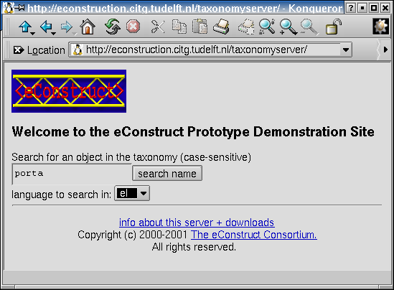

The second screen shows a list of matches, select one and continue.
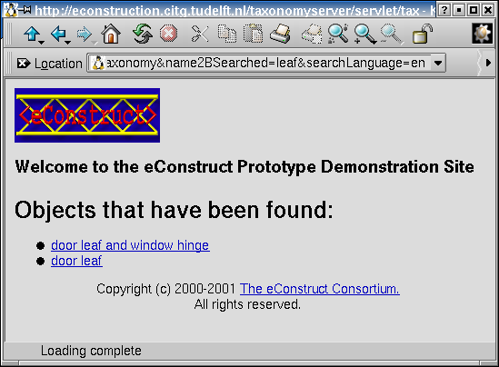
The thirth (and most important) screen shows a hierarchy on the left hand side and the properties of the currently selected object on the right hand side. The hierarchy can be used to select either more generic or more specialised objects, according to preference. Once the best fit has been found, the appropriate values to search for can be filled in at the right hand side of he screen.
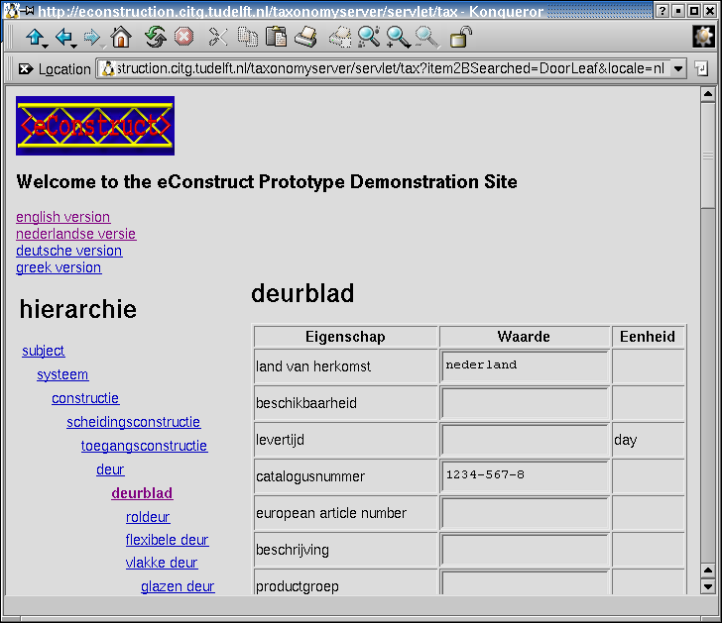
Pressing enter generates the bcxml query and shows a list of catalogues. Select one to search in that catalogue. (Which passes you into the realm of the supplier catalogue server).

Obtaining the source code
The source code can be obtained using CVS from sourceforge, module name "bcxml".

References
[concur] Brite-EuRam BE 96-3016: CONCURrent Engineering in Building and Civil Engineering.
[econstruct] Michel Bohms. econstruct web-site. On-line at econstruct.org.
[garm] W.F. Gielingh 1988: General AEC Reference Model (GARM). TNO Building and Construction Research, BI-88-150, Delft, The Netherlands
[isopas] ISO 2000. ISO PAS 12006-3 Building Construction – Organization of information about construction works – Part 3: Framework for object oriented information exchange. On-line at icis.org .
[lexiconconvertor] Reinout van Rees. lexiconconvertor program. On-line at bcxml.sourceforge.net .
[lgpl] Richard Stallman. Library GNU Public License. On-line at gnu.org .
[opensource] open source web-site. On-line at opensource.org.
[sourceforge] sourceforge download site. On-line at sourceforge.net.
[soap] SOAP simple object access protocol specification. On-line at w3.org.
[stabu] Stabu foundation web-site. On-line at stabu.nl.
[unittest] unit tests. J. Donovan Wells. On-line at extremeprogramming.org .
[xalan] Apache xalan xslt processor. On-line at xml.apache.org .

